Unit 6: Local coastal fisheries

Student outcomes: understanding of what constitutes coastal fisheries and the key biological, social and economic characteristics of PNG and Solomon Islands coastal fisheries

UNIT 6a. Papua New Guinea Coastal Fisheries

Activity 6.1: Assess prior knowledge by class discussion of their understanding of coastal fisheries in their country

What are Coastal Fisheries?
Fishing in PNG fisheries waters is broadly divided into 2 main categories. The first category is Offshore or Oceanic fishing. This type of fishing takes place in the sea area far away from the coastline mainly in the area known as the Exclusive Economic Zone (EEZ) and the Archipelagic waters. Large industrial-scale purse-seine and longline fishing vessels are mainly used in the offshore fisheries.

The second category of fishing is Coastal Fisheries which is the focus of this Unit. Fishing that takes place on fringing reefs, barrier reefs, lagoons, estuaries and neashore areas from the shoreline to about 6 nautical miles offshore are generally known as Coastal Fisheries. The resources that support coastal fisheries are characterised by a shallow-water habitat, demersal lifestyle, restriction of individual movements to coastal areas and, in most cases, a more restricted larval dispersal (see Gillett, 2010²). Recent recruitment and connectivity studies in Manus and Kimbe by a group of institutions including James Cook University suggest that some reef fish species are self recruiting to the same reef areas and get recruits from adjacent reefs.

Coastal fisheries can be divided further into into three categories;
- Small Scale Commercial Fishing also known as Artisanal Fishing
- Subsistence Fishing
- Industrial Scale Prawn fishing.

About 300 species of the estimated 2,000 species of reef fish found in PNG are exploited by the coastal fisheries sector on a regular basis. In addition, a large number of shells and other sedentary species are also exploited. PNG has an extensive coastline of 21,250 km and a reef systems that is generally healthy. Approximately 61 % of the PNG population live within 100 km of the coastline (Table 6.1). The estimated total coastal fisheries production for PNG in 2007 was 35,000 tonnes with subsistence harvesting accounting for 80% of this production.

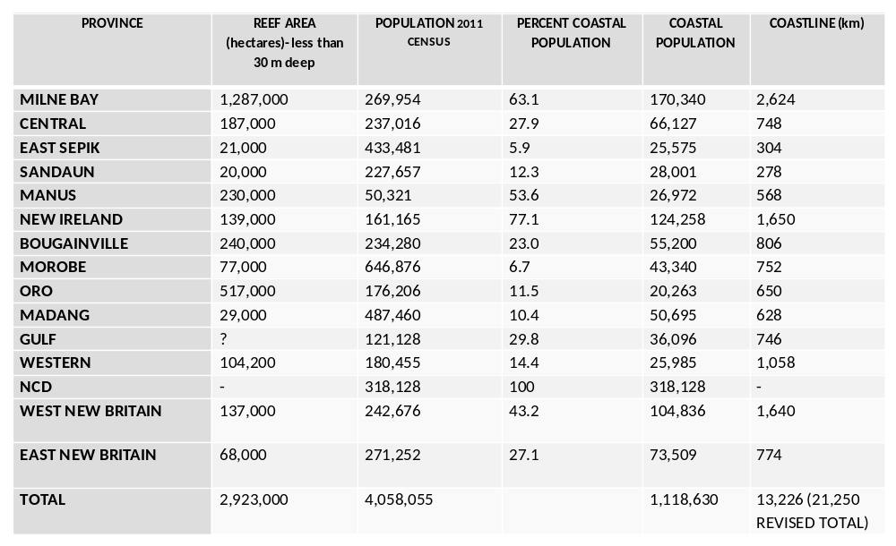
Table 6a.1. Estimates of the total coastal fishing area available in PNG with an indication of human population sizes that potentially rely on these areas for fishing.

Small Scale Commercial Fishing (Artisanal Fishing)
Small Scale commercial fishing use small motorised boats and simple low maintainance fishing gear. In PNG and other parts of the Pacific Islands, small scale commercial fishing is done primarily for sale of fish and other marine organisms at local markets or for export to overseas markets.

Small Scale Commercial Fishing for Local Markets
The vessels used in this sub-category of coastal fisheries are normally smaller than those used in Asia and other parts of the world. The most common vessels used are 19 to 21 foot fibreglass dinghys powered by 40 HP outboard engines. Village canoes are more commonly used by the coastal and Island communities. Wading and gleaning on the reef flat during low tide is also common especially for the collection of sedentary organisms such as clams and other shells.

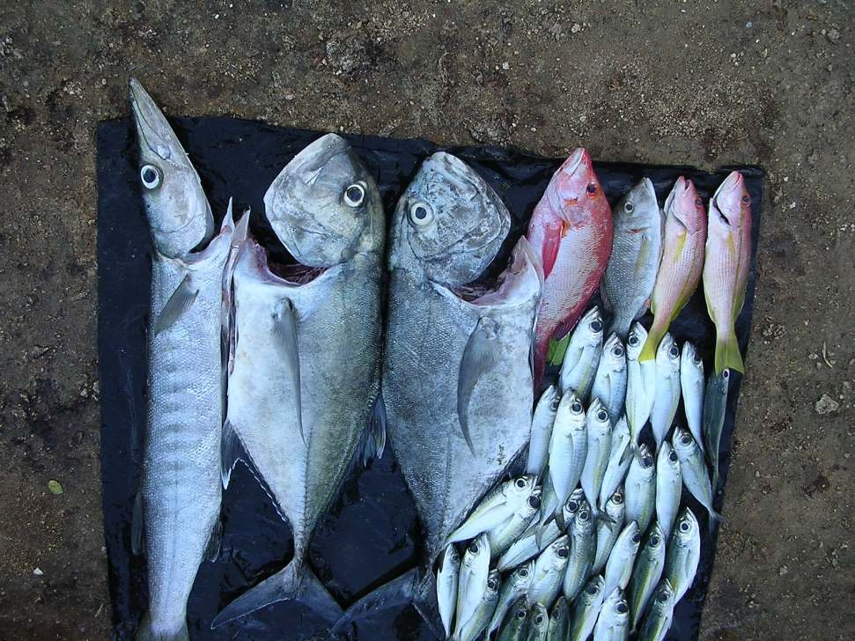
Figure 6a.1. Fresh fish being sold at the Kavieng fish market, PNG. Photo: Paul Lokani.

Fishing methods commonly used in small scale fishing for local markets include handlining, trolling, drop lining, surface spear fishing, underwater spear fishing, hand collecting, gill netting and surround netting. The main driver for the small scale commercial fishing for local markets are local urban markets located in all the 14 coastal provinces. Some provinces have a number of urban centers and therefore have a number of urban markets. Local shops and local restaurants also buy fish and other marine products from the small scale commercial fishermen.

To better understand the key characteristics of the Small Scale Commercial Fishing for local markets, two examples are given below: the Port Moresby Artisanal Reef Fishery and the Madang Inshore Fish Aggregation Device Fishery.

Example 1: Port Moresby Artisanal Reef Fishery
The Port Moresby Artisanal Reef Fishery (see area map in Figure 6a.4) was studied by Lock (1986) in the mid 1980’s. A fleet of 71 vessels comprising motorised dinghy’s and sailing canoes crewed by 284 full time fishermen fished in close proximity to the urban markets in Port Moresby. The fishery was concentrated on the fishing areas around the surrounding fringing reefs and barrier reefs in five villages to the west of Port Moresby.

Eight different fishing methods were used in the fishery with fishermen shifting gear according to the weather patterns and seasonality of fish. Fishing methods used by the fishery were:
- Surround Net
- Drive Net
- Handline
- Surface spear
- Underwater spear
- Trolling
- Barrier Net
- Gill Net

Lock (1986) Error: Reference source not found recorded 24 families of fish caught by the fishery (see Table 6.2). Surround net accounted for 33% of the catch and drive net accounted for 28% of the catch. Annual fish catch per vessel ranged from 3.6 to 12.9 tonnes. Average yearly catch for the fishery was over 500 tonnes.

Table. 6a.2. Total Annual Landings (kg) by the Port Moresby Artisanal Reef Fishery. Source: Lock (1986) Error: Reference source not found.
Common Name | Family | Total Annual Landing (kg) | Composition %
Sharks | Carcharhinidae | 4,192 | 0.7
Rays | Myliobatidae | 2,101 | 0.4
Milkfsh | Chanidae | 2,976 | 0.5
Half-beak | Hemiramphidae | 6,047 | 1.1
Longtom | Belonidae | 29,806 | 5.2
Grouper | Serranidae | 14,329 | 2.5
Jacks | Carangidae | 48,102 | 8.3
Snapper | Lutjanidae | 27,316 | 4.7
Silver Biddies | Gerridae | 9,882 | 1.7
Sweetlips | Haemulidae | 22,298 | 3.9
Emperor | Lethrinidae | 168,947 | 29.3
Seabream | Sparidae | 1,039 | 0.2
Goatfish | Mullidae | 25,881 | 4.5
Batfish | Ephippidae | 1,260 | 0.2
Bluefish | Kyphosidae | 5,398 | 0.9
Mullet | Mugillidae | 23,223 | 4.0
Barracuda | Sphyraenidae | 4,106 | 0.7
Wrasse | Labridae | 4,572 | 0.8
Parrotfish | Scaridae | 29,959 | 5.2
Unicornfish | Acanthuridae | 39,533 | 6.8
Rabbitfish | Siganidae | 31,897 | 5.5
Tuna and mackerel | Scombridae | 58,462 | 10.1
Triggerfish | Ballistidae | 2,211 | 0.4
Other |  | 13,840 | 2.4
Total |  | 577,377

Example 2: Madang Inshore Fish Aggregation Devices Fishery
The Madang Inshore Fish Aggregation Devices (IFAD) fishery (see area map in Figure 6a.4) recently started around 2007. The fishery is based entirely on fishing IFADs. About four IFADS were deployed by RD Fishing along the coast of Madang that could be accessed from Madang Town in 1 to 2 hours as part of its social responsibility to help local fishermen. An estimated 60 dinghys powered by 40 HP regularly fish the IFADS. A number of IFADS were also deployed around Karkar Island for use by local Karkar Island fishermen. Observations and interviews with villagers at Karkar indicate extensive use of IFADs at Karkar Island by canoe fishermen. Between 50 and 70 canoes normally fish around a single IFAD at Karkar when the tuna aggregate in large numbers.

The main target species of the IFADs fishermen are skipjack tuna, yellowfin tuna, sailfish and marlins. Other species such as rainbow runners and dolphin fish are also caught on the IFADs. There are two main types of vessels used by the fishery: 21 foot fibre glass dinghys powered by 40 HP with 3 fishermen in each dinghy;

and small canoes with one fishermen using paddle power (mainly at Karkar Island). There are approximately 180 fishermen in total who crew the dinghys that fish the IFADs. Both canoe fishermen and dinghys normally leave for the IFADS very early in the morning before sunrise around 5 am and fish around the IFADs for half a day or full day depending on the catch before they go home to sell the catch.

At Karkar Island women sell the catch for the canoe fishermen at the local Island markets or sell them on the mainland of Madang. Women also sell the catch of the dinghy fishermen, mainly at the Madang town markets. Fish are sold acording to size of the fish or the portion of the fish. Large fish such as marlin and sailfish are normally chopped into steak portions and sold for K4.00 each. A 30 cm fish is sold for about 20-30 kina per fish. Each Dinghy spends between 90 and 180 kina on a daily basis for fuel. Each dinghy therefore targets to catch enough fish to break even or make a profit. The Madang IFAD fishery is conservatively estimated to land 300 to 400 tonnes per year worth over 3 to 4 million kina.

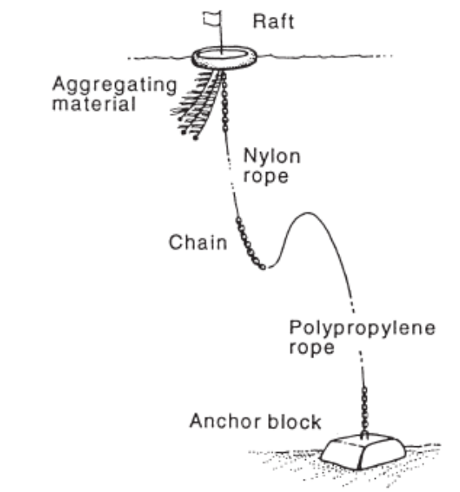

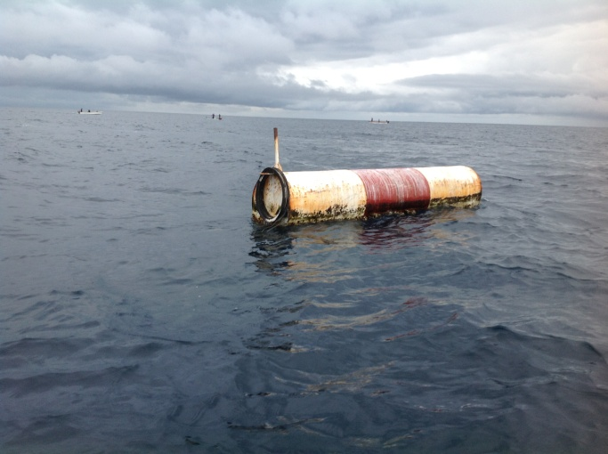
Figure 6a.2. A fish aggregating device (FAD) now commonly used in deep open ocean areas in throughout the Pacific to enhance fishing opportunities. Above shows a diagram of how they are constructed and anchored (King, 1995Error: Reference source not found), and below shows the surface view of a FAD (Photo: Paul Lokani).

Small Scale Commercial Fishing for Export
Infrastructure, logistics and the high cost of freighting fish and other marine products to markets have limited the full development of the small scale commercial fisheries in PNG. However, small scale fishing for the high value species which require no specialised preservation has been the focus of efforts of small scale fishermen. Species requiring little or simple preservation methods include sea cucumbers which are processed into beche-de-mer, trochus shells, pearl shells, shark fin and crabs. All the export targeted species attract high prices and therefore fisher folks target them often leading to over-harvesting. Lobster, aquarium trade species and live fish trade species are also high value export target species but require more specialised and technical skills to handle properly for export.

The current export driven fisheries have similar characteristics that include the following;
- High Value
- Easy to harvest requiring simple fishing gear
- Require minimal capital investment (except live fish and Aquarium Trade)
- Heavily fished
- Often over-fished
- Simple preservation methods

A brief description of two of the export fisheries (beche-de-mer and trochus) are given below.

Beche-de-mer fishery
Despite management of the fishery under the beche-de-mer fishery management plan, the fishery has been heavily overfished. The fishery is currently closed for 6 years due to overharvesting and continously exceeding the total allowable catches for the provinces. The characteristics of the fishery prior to this closure are summarised below.

Of the 1.1 million people who live on the coast and islands in PNG it is estimated that between 200,000 and half a million people were involved in the harvesting and processing of sea cucumbers. Harvesting of sea cucumber is very simple and involves reef walking and collecting sea cucumbers during low tide or snorkelling. Traditional canoes with paddle power was the main vessel used by the fishery but outboard powered dinghys were commonly used as well to reach distant reefs. Most of the collection of sea cucumbers was on the reef flats but fisher folks also collected from the reef slopes and lagoon floor within breathholding limits. More than 21 species of sea cucumbers have been harvested in PNG.

Distribution patterns of each sea cucumber species is habitat dependent. Some species such as sandfish are only found in sandy lagoon areas and grassy sand beds. The surf redfish on the other hand is only found in high energy areas where there are breaking waves. Most of the species spawn between November and January but are highly dependent on high density for successful fertilisation. Sustainability of the fishery is therefore dependent on maintaining a high spawning population density. It is therefore important that fishermen don‘t harvest every sea cucumber they see.

After collecting sea cucumbers, the specimens go through a process of boiling and sun or smoke drying before they are sold to beche-de-mer buyers and exporters. In 2001 PNG exported 503 tonnes valued at K17.8 million with the low value species accounting for more than 60% of the total export. Between 2000 and 2009 PNG exported a total of 5.5 million tonnes of beche-de-mer with an export value of 296 million kina. Average annual production for the same period was 555 tonnes with an average annual value of K29 million. Export peaked at 795 tonnes with an export value of 52 million kina in 2007. This dropped to 537 tonnes valued at 36 million kina in 2009 when the fishery was closed. PNG used to supply 10% of the global beche-de-mer market.

Trochus fishery
Trochus (Trochus niloticus) is a dried product that is harvested by local communities and sold to traders, exporters and processors. Harvesting involves snorkelling and hand collecting the trochus shells. The shells are collected for the production of quality buttons and ornaments made from its nacrenous inner layer. The powdered scraps resulting from button manufacture are used in lacquers and shampoos. The shell trade is important to coastal communities as it does not require large investment or specialised equipment and the product is non-perishable. The easy access to the resource also makes it susceptible to over-harvesting.

Trochus is graded into three categories (small, medium and large) and can be exported either as unprocessed or as buttons. There is no management plan for this fishery but there are specific size limits set out in the national gazette number G57 of 4th April 2002 which provides the basis for regulating the size of trochus shells that are harvested. The highest quantity of trochus buttons exported was in 2000 with 39.9 mt however the value of trochus buttons earnings peaked at US$3.1million in 1996 and 1997.

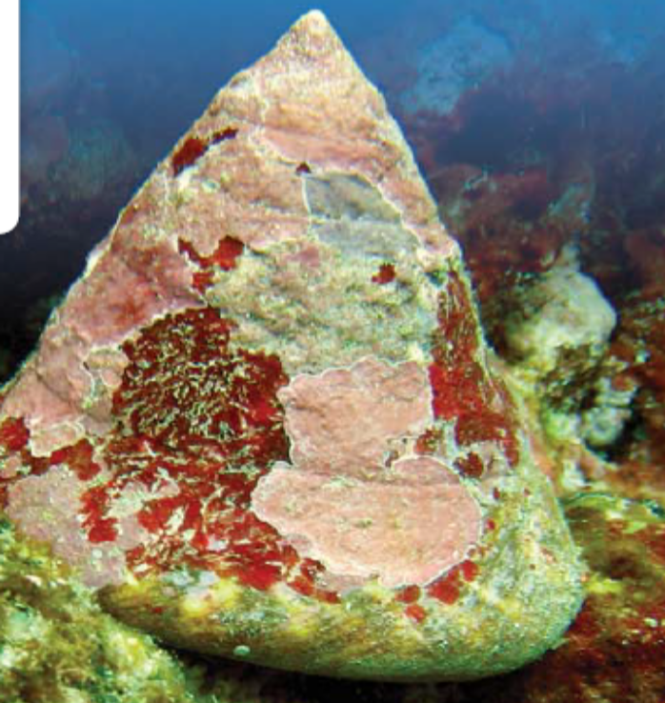
Figure 6a.3. Algal encrusted trochus shell on a coral reef. Source: SPC (2011) Guide and information sheets for fishing communitiesError: Reference source not found.

Industrial Scale Prawn Fishing
There are 3 main prawn fisheries in PNG located in the Gulf of Papua, Torres Strait Protected Zone and Orangerie Bay. All three fisheries use industrial trawlers which unfortunately result in a high volume of bycatch. There are more than 40 species of prawns found in Papua New Guinea but only a few species are commercially fished. The main commercial fishery is the Gulf of Papua Prawn Fishery where the main target prawn species are the banana prawns (Penaeus merguiensis and P. indicus), black tiger prawns (P. monodon) and endeavour prawns (Metapenaeus ensis, M. demani).

The production level from the Gulf of Papua Prawn fishery varies from 400–1300 (all species) tonnes per year. Ninety percent of the prawns are exported. About 50-60 % of the catch consists of banana prawns (P.merguiensis and P.indicus), 10-15 % tiger prawns (P. monodon and P. semisulcatus), and 15-20% endeavour prawns (M. ensis, M.endeavouri and M.demani). The rest is mostly packed as mixed grades, consisting of broken tails and soft shell prawns. The Gulf of Papua Prawn Management Plan restricts the total of number of prawn trawlers to 15. The plan also restricts participation in this fishery to companies owned by PNG citizens. The 15 vessels are operated by 7 companies. Some of these vessels were built in the 1950s and used to operate in the Gulf of Carpentaria Prawn fishery before being resold to the current operators in PNG. The rise in costs of fuel coupled with the need for occasional maintenance of the vessels has increased the costs of operation for the companies.

The Torres Strait Prawn Fishery is jointly managed with Australia under the Torres Strait Treaty. The number of prawn trawlers varies and is limited because of the high cost of operating the fishing vessels away from Port Moresby where the prawn trawlers are normally resupplied however some companies operate from Daru.

The Orangerie Bay Prawn Fishery normally has one boat and is managed under a management plan. Unfortunately the fishery is closed due to a conflict between the surrounding communities and the company operating the prawn trawler. The fishery is normally worth about K100,000.00 annually.

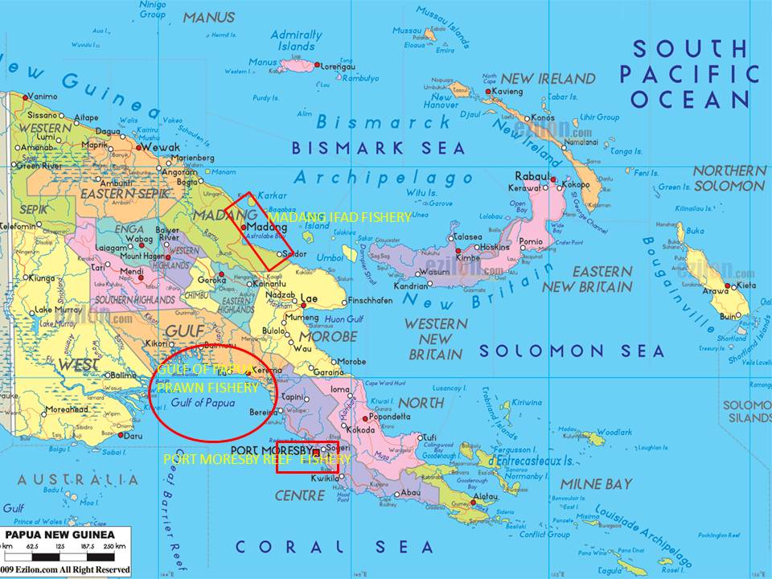
Figure 6a.4. Map showing the area for the main commercial prawn fishery in the Gulf of papua, PNG. The map also shows the main areas for the Madang IFAD fishery and the Port Moresby reef fish fishery. Source: Paul Lokani.

Subsistence Fishing
Subsistence fishing refers to fishing carried out by local communities for their own consumption and for cultural purposes as their ancestors have done for thousands of years. Both traditional fishing gears and more modern conventional fishing gears are being used today. Fishing normally takes place in traditional fishing areas owned by the clan or the community. Of the 4 million people who live in the 14 coastal provinces of PNG, an estimated 1.1 million people depend on their daily food and nutritional requirements from the sea (2010 National Census)Error: Reference source not found.

Typical characteristics for subsistence fishing in PNG are:
- Fishing is based on traditional, customary and cultural norms.
- There are certain fishing methods for women and others for men.
- Women and the young commonly do reef gleaning to collect sedentary species such as clams and other shells.
- Mostly traditional canoes are used in fishing.
- Traditional management is practised in some areas.
- Some types of fishing gear are labour intensive requiring communal efforts.
- The catch is shared among family members.
- Part of the catch is often used for exchange of vegetables and other garden foods.

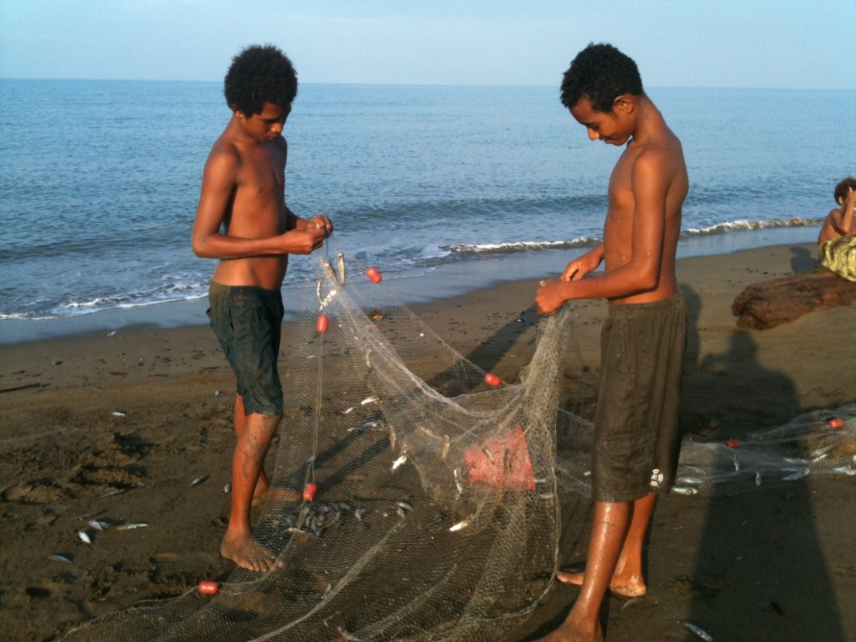
Figure 6a.5. Young villagers using a modern gillnet to target schooling baitfish, PNG. Photo: Paul Lokani.

Traditional canoes on paddle power are the main fishing vessels used in the subsistence fishery but there is an increasing trend to use more modern vessels such as fibreglass dinghy’s powered by outboard motors. Subsistence fishing mainly takes place on the reefs, in lagoons, estuaries and mangrove swamps. A variety of traditional fishing gears are used but modern gear such as nylon fishing lines and nets are commonly used.

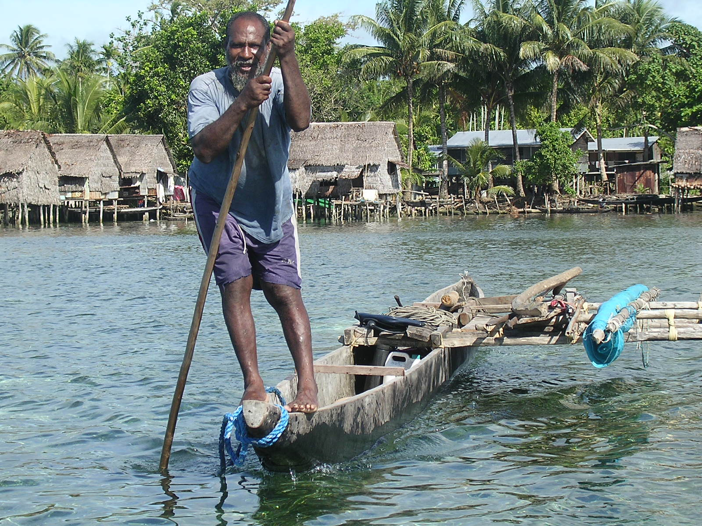
Figure 6a.6. A PNG fisherman using a traditional canoe. Photo: Paul Lokani.

Reef gleaning is mainly undertaken by women. Women account for more than 50% of the subsistence catch in some places. Gillett (2010) estimates that the subsistence catch for PNG is approximately 30,000 tonnes per year and valued at $US1.82 per kilogram. This is equivalent to K109 million kina per year.

The number of species targeted by the subsistence fishery is not known but is easily more than 500 species. In general all edible fish and marine organisms are taken at some point in time. There is a general trend emerging that as some species of fish and marine organisms get overharvested communities shift to other species not targeted in the past to meet their food and nutritional requirements.

Activity 6.2: Select one of the export-based Artisanal fisheries identified above (Beche-de-mer, Lobster or Trochus), or another you know about, and describe its key characteristics. This should include aspects such as: species targeted, their life history & biology, where are they caught, who catches them, what methods/gears are used, catch volumes and trends, management, how many vessels, how much is exported, etc. (30 min)

Further reading
Taken from National Coral Triangle Initiative Coordinating Committee of Papua New Guinea (2012), unless otherwise stated:

Subsistence and artisanal fishery
“Although the commercial sector is the major fishery in terms of catch weight, subsistence and artisanal fisheries are arguably more important in socio‐economic terms. Fish is the major source of protein for the

coastal populations throughout the Papua New Guinea mainland and islands, and is a part of the staple diet in these areas.

Fish are also one of the main sources of cash income for coastal communities, many of whom will take their catch 100 kilometres or more to reach a market where they can be sold for cash. In many communities, fish that are not consumed immediately and those that will be taken to market, are smoked to extend their “shelf‐life”, as fresh fish deteriorate rapidly in the tropical climate. The subsistence and artisanal sector provide most of the fish for the domestic market, and for export, including niche markets such as shellfish and beche‐de‐mer. The beche‐de‐mer fishery is reported to be the most valuable coastal fishery in Papua New Guinea.

The subsistence and artisanal fisheries are concentrated in coastal and near‐shore waters (generally within the 3‐mile limit), and use a variety of methods, depending on the target catch. Although these fisheries have supported the coastal populations of Papua New Guinea for centuries, the rapid growth in coastal populations and the increasing demand for cash income has in recent years led to an increase in subsistence and artisanal fishing activity, raising serious concerns over the sustainability of coastal fish stocks.

This is particularly so for those species that have a high export value, such as beche‐de‐mer and some shellfish such as trochus and the giant clam, which attract high overseas earnings and are therefore particularly at risk of overharvesting in a cash‐poor economy. Rural island households in Milne Bay Province have responded to their loss of purchasing power (the effects of inflation and decreasing commodity prices such as copra) and the increasing demand for sedentary fish products by increasing their harvesting levels of commercially valuable species.

Although anecdotal evidence increasingly suggests that some of these coastal stocks are declining, there appears to be a lack of reliable and accurate information on either coastal fish stocks or fish catches, so that accurate estimates of sustainable yield cannot be calculated, or indeed how serious the risk of overexploitation is at the current levels of fishing. In these circumstances, a precautionary approach should be adopted. However, subsistence and artisanal fisheries are, by their nature, difficult to manage and regulate by government agencies. Experience to date suggests that sustainable management of these fisheries is best achieved through a combination of agency regulation and community based awareness programs and local skills’ development programs for the local fishing communities. These should be designed to engage and then empower the local fishing communities to monitor and manage their own local fisheries resources in a more sustainable manner.

There is considerable concern, at both local and national levels, over recently introduced destructive fishing methods such as poisoning with derris powder and dynamite fishing. These methods are non-selective in impact and destroy large numbers of individuals of all species, and in the case of dynamite fishing, physically destroy the habitat as well.”
Commercial fishery
“The main commercial fishing species are tuna and prawns. A total of 19 prawn vessels operate in PNG. Of the total, fifteen domestic prawn trawlers operate in the Gulf of Papua Prawn Fishery, while one operates in the Orangerie Bay Prawn Fishery and three in the Torres Strait Fishery. In the Gulf of Papua fishery, a total annual catch from all species of prawns is on average about 1, 000 metric tonnes (tail weight) per annum, with an estimated value of K10 million (AUS$ 5 million). The fishery remains closed to foreign involvement. Prawns are processed and packed on board and mainly exported to Japan, Singapore and

Australia or are sold domestically within PNG. The fishery is managed under the Gulf of Papua Prawn Fishery Management Plan. The fishery is believed to be nearing its catch potential and with the increase efficiency in fishing effort has raised concerns.” (http://fisheries.gov.pg.dnnmax.com/ Accessed 24/9/12)

The prawn and lobster fisheries in the Torres Strait Protected Zone are being co-managed with Australia under the Torres Strait Treaty Arrangements. The management is aimed at preserving the fishery for the traditional inhabitants, with strict limited entry for non-inhabitants. The lobster fishery currently involves more than five hundred divers annually and generates an annual estimated average of about 80 mt, worth approximately a little over K4 million in exports alone. The prawn fishery has still availabilities for more active fishing vessels to participate. Restrictions and high fishing operational cost appear to make this fishery less economic than the Gulf of Papua prawn fishery. An annual harvest of prawn (all species) was worth approximately K3 million in exports alone and products exported to Asian markets. (http://fisheries.gov.pg.dnnmax.com/ Accessed 24/9/12)

The Orangerie Bay Prawn fishery has one active vessel. The annual export value of prawns (all species) from Orangerie Bay fishery is worth an approximate of K100,000. The Orangerie Bay Prawn Fishery Management Plan manages the fishery. (http://fisheries.gov.pg.dnnmax.com/ Accessed 24/9/12)

“The Papua New Guinea (PNG) tuna fishery is made up of both the purse‐seine and longline sectors with a small, but important handline sector. The longline and handline sector is a citizen‐only activity and all vessels fish exclusively in the waters under PNG national jurisdiction. The purse‐seine sector is a mix of both domestic and foreign access vessels. A total of 256 vessels were active in the PNG waters in 2010. Thirty‐two (32) were longline and handline vessels and 224 were purse‐seine vessels.”

Fisheries degradation and food security
“A significant loss of coastal fisheries is very evident along the coastline of PNG. Major populated provinces that have depended heavily on their marine resources to sustain their livelihoods have become under stress from fishing pressure and the methods of fishing while other factors including easy access to distant or protected fishing grounds by outboard powered engines and fiberglass boats. Many of the 14 Maritime Provinces have agro‐forestry projects located inland. These projects have over the last 20 years have contributed immensely to the degradation of the marine resources and their habitats and the other major form of degradation is from natural seasons of heavy rainfall and long drought spell.

Food security has been a very serious problem mainly with coastal province which have major gold and copper mines located within their provinces. The Western Province located southernmost part of PNG bordering Indonesia has been recently impacted by recent flooding caused by heavy rains further up the Fly River. A total of 15 villages located along the coast were inundated by flooding which has destroyed food gardens, smothered sea grass meadows, caused flooding to tributaries and has prompted most of the marine resources to become unsafe to eat. Comparison from the last 12 months have recorded over 15% of men, women and children that are experiencing symptoms of arthritis, serious skin diseases, allergies, complications of women in child birth, and unknown death related to eating of reef fishes.”

References & further reading:
Anon. (2010) National Fishery Sector Overview of Papua New Guinea. FAO, RomeError: Reference source not found.
Gillett, R., (2010) Marine fishery resources of the Pacific Islands. FAO Fisheries and Aquaculture Technical Paper 537.Error: Reference source not found

Gillett, R and Cartwright, I. (2010) The future of Pacific Island fisheries. Secretariat of the Pacific Community and Forum Fisheries Agency. Error: Reference source not found
Lock.J.M, (1986) Study of the Port Moresby Artisanal Reef Fishery. Technical Report 86/1. DPI. Error: Reference source not found
National Coral Triangle Initiative Coordinating Committee of Papua New Guinea. (2012) State of the Coral Reefs of Papua New Guinea. Government of Papua New Guinea, Port Moresby.Error: Reference source not found
Pratchett, M. S., P. L. Munday, N. A. J. Graham, M. Kronen, S. Pinca, K. Friedman, T. D. Brewer, J. D. Bell, S. K. Wilson, J. E. Cinner, J. P. Kinch, R. J. Lawton, A. J. Williams, L. Chapman, F. Magron, and A. Webb. (2011) Vulnerability of coastal fisheries in the tropical Pacific to climate change. Pages 493-576 in J. D. Bell, J. E. Johnson, and A. J. Hobday, editors. Vulnerability of tropical Pacific fisheries and aquaculture to climate change. Secretariat of the Pacific Community, Noumea.Error: Reference source not found
Secretariat of the Pacific Community. (2011) Guide and information sheets for fishing communities. Secretariat of the Pacific Community, Noumea.Error: Reference source not found
Willmann, R. and K. Kelleher. (2010) Economic trends in global marine fisheries. Pages 20-42 in R. Q. Grafton, R. Hilborn, D. Squires, M. Tait, and M. J. Williams, editors. Handbook of marine fisheries conservation and management. Oxford University Press, New York. Error: Reference source not found
Also see: http://www.fisheries.gov.pg/

UNIT 6b. Solomon Island Coastal Fisheries

Activity 6.1: Assess prior knowledge by class discussion of their understanding of coastal fisheries in their country

Coastal fisheries in the Solomon Islands
All references used in this section are on the EAFM CD under “Further Reading“ and “Solomons Fisheries Information“ unless otherwise indicated.

The Solomon Islands is made up of approximately 990 islands that form a double-chained archipelago. There are 6 main islands that make up a total land area of 27,556 km² and have a total Exclusive Economic Zone (ocean) area of approximately 1,553,444 km² (Bell et al, 2011). There is an important tuna fishery in the Solomon Islands, however, this is mainly an off-shore fishery (therefore its management is not addressed in this course) and mainly comprised of a foreign fleet. This fishery brings about US$4.5 million/year (~SBD$31 million) to the government in licensing (Sulu et al 2012).

Coastal fishing occurs on fringing reefs, barrier reefs, atolls, lagoons, intertidal reef flats, estuaries and neashore areas. In 2007 the total annual coastal fisheries catch was estimated to be 18,250 t with approximately 3,250 t being commercial catch and the remainder subsistence.

Coastal fisheries target four major species groups:
- Demersal species – bottom-dwelling fish associated with coral reefs, mangroves and seagrass habitat,
- Nearshore pelagic fish – includes tuna, Spanish mackerel, mahi mahi, wahoo and rainbow runner,
- Invertebrates targeted for export, and
- Invertebrates gleaned from intertidal and subtidal areas (Bell et al, 2011)Error: Reference source not found.

Demersal fish species make up nearly half (49 %) of the total coastal fisheries catch by weight followed by nearshore pelagic species (31 %), inter/subtidal invertebrates (15 %) and invertebrates for export (5 %) (Bell et al, 2011) Error: Reference source not found. Of the demersal fish species the tropical snappers (Lutjanidae) are the single most commonly taken Family (18.1 %) followed by Serranids (13.1 %) (Figure 6b.1). The composition of species in the catch varies greatly throughout different regions of the Solomon Islands.

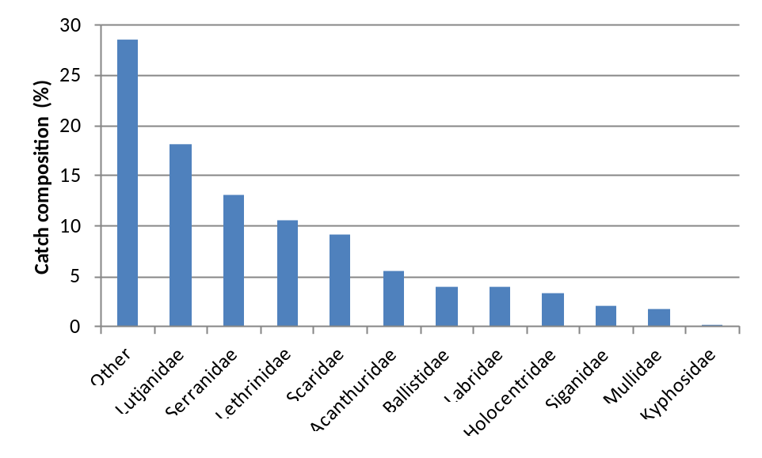
Figure 6b.1. Composition of catch of demersal fish species by family throughout the Solomon Islands. Adapted from Bell et al, 2011Error: Reference source not found.

Nearshore pelagic fish species are targeted using trolling methods or line fishing methods around FADs. The species targeted include tuna and mahi mahi, with Spanish mackerel being especially important. Of the invertebrate species targeted for export sea cucumbers and trochus have been the most important being of high value. Both sea cucumber and trochus have been heavily exploited in the Solomon Islands until a national ban on the harvest of sea cucumber species in 2010. Trochus continues to be heavily harvested but is showing similar trends of overfishing as seen with sea cucumber (Sulu et al, 2012). Invertebrate species that are harvested by gleaning are diverse however giant clams make up approximately half of the total annual catch (Figure 6b.2).

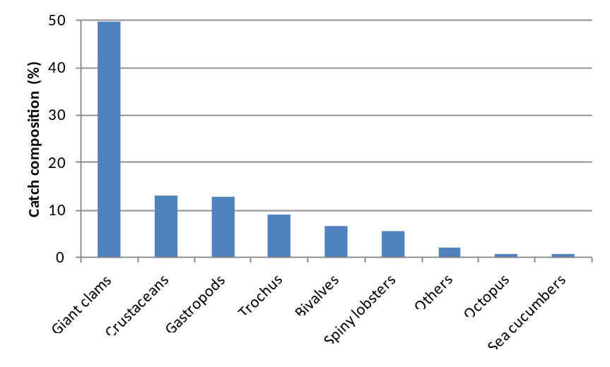
Figure 6b.2. Composition of catch of invertebrate species caught by gleaning throughout the Solomon Islands. Adapted from Bell et al, 2011Error: Reference source not found.

In the Solomon Islands coastal fisheries fall in to two main categories:
- Subsistence fishing
- Small scale fishing

Subsistence fishing
(Source: Sulu et al, 2012)
The subsistence economy is the mainstay of rural Solomon Islands, with coastal fisheries having a vital role. Fishing and gardening is the main livelihood of rural communities. There are no figures on the actual extent of fishing activities in the country let alone subsistence fishing, however, it is estimated that nearly half of all women and 90% of men fish. In most rural households, at least one member of each household is involved in fishing. Fishing is mostly done in wooden dugout canoes, and motor powered fibreglass boats, using simple fishing gear like handlines, nets or spears.

Surplus garden and fishing products are often either shared with other community members or sold for cash income to purchase household necessities. Depending on household needs, a greater proportion of fish catch (usually the best) will be sold either fresh or cooked at local markets. Other forms of cash-earning livelihoods are limited due to the lack of transport and processing infrastructure, and the non-existence of microcredit schemes that can be accessed by households in rural areas. More than half (56%) of rural households in the Solomon Islands rely on home production as the main source of income compared to only 5% in the urban areas. Fish (includes shellfish and other inshore marine resources) plays a pivotal role in food security and income generation for Solomon Islanders. Solomon Islands have one of the highest per capita consumption rates of fish in the world. Although different estimates have been provided over time and by different sources, a recent study estimated that the average annual per capita fish consumption (kg yr-1) in urban areas was 45.5 kg yr-1, in the rural areas it was 31.2 kg yr-1 while the national average was 33 kg yr-1 (90% of this consisted of fresh fish). The global average is 16kg/yr (Willmann and Kelleher, 2010Error: Reference source not found). However, the figures for Solomon Islands may be an underestimation.

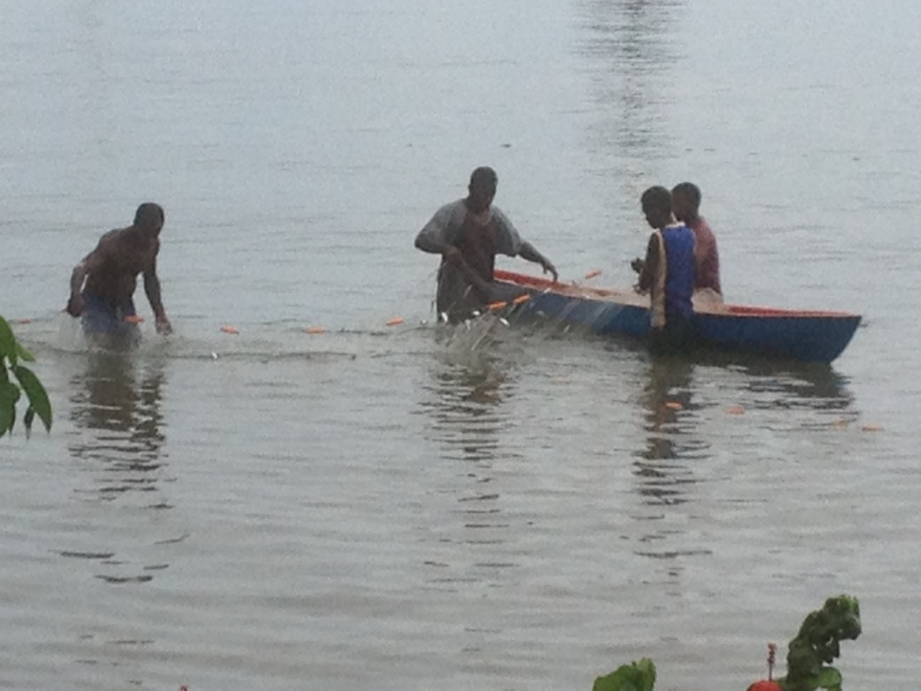
Figure 6b.3. A canoe used in conjunction with a modern gillnet to target schooling baitfish in a bay near Honiara, Solomon Islands. Photo: Dave Welch.

Small scale Fisheries
(Source: Sulu et al, 2012)
Most rural fishers sell their catch when their household needs dictate it. There are also fishers who fish to sell at urban areas around the country, predominantly at Honiara, although there are also some who sell at the provincial urban centres like Auki (Malaita), Gizo and Munda (Western Province), Tulagi (Central Province), Kirakira (Makira) and even as far as Bougainville markets for communities near the Papua New Guinea border. These nearshore fishing activities are what is referred to here as small scale fisheries. In 2006, it was estimated that 16% of households in self-employed commercial activity were engaged in the sale of fish and other seafood.

The Ministry of Fisheries and Marine Resources (MFMR) established Rural Fisheries Centres (RFCs) in nine Provinces in the mid to late 1990s (funded by various donors). The aim of these RFCs was to stimulate rural development and income generation through fisheries development. The RFCs provide ice for fishermen and buy fish from fishers for sale elsewhere, in most cases for transport to Honiara where fish were sold at the Honiara market or directly to hotels and restaurateurs. Export trials to Australia were also conducted. In 2007, only 11 of the 30 RFC’s were deemed reasonably successful (Lindley 2007Error: Reference source not found). Major factors besetting the endeavour were lack of maintenance of the facilities at the RFCs and poor transportation between the RFCs and Honiara; where transportation was available the high transportation cost of fish from distant provinces made then uneconomical, especially when they had to compete with fish from fishers from Honiara, Nggela and Russell Islands which are closer to Honiara. With support from various aid donors, several of RFCs are now undergoing repairs.

The RFCs were an important source of cash income for fishers as livelihood options are limited and more so when the important sea cucumber fishery that many relied on has been closed since 2010. While there are no real estimates for the total value of the fish from these RFCs and other private fishing centres, it is estimated that rural communities provide SBD$5 million dollars worth of fish to the capital city on annual basis.

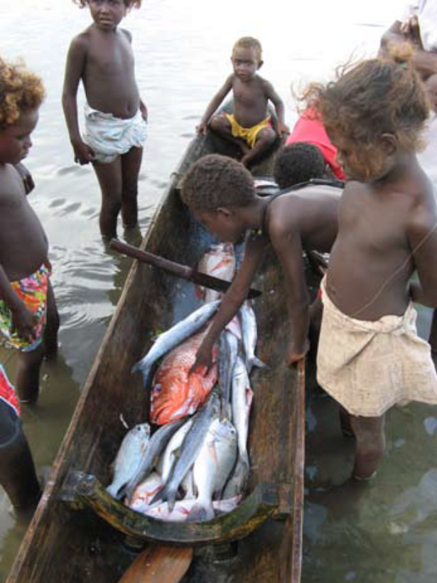
Figure 6b.4. A typical multi-species catch of demersal fish taken in Solomon Islands. Source: MFMR 2010.

Reef finfish fisheries provides approximately SBD$21.6 million (Solomon Dollars) per annum in income to fishers and traders involved in the reef fisheries market (Brewer 2011Error: Reference source not found). Note that Brewer’s (2011) estimate was predominantly based on reef finfish fisheries and does not consider the marine ornamental trade, trochus fisheries or beche-de-mer fisheries (currently closed) which contribute significantly to income generation for Solomon Islanders, particularly those living in rural areas. The overall income value of the reef fisheries therefore could be considered substantial.

Invertebrate species that are mainly targeted by coastal communities are trochus and sea cucumber. They are easy to harvest and non-perishable, important factors as most coastal communities have poor storage facilities and transportation services. For the decade ending 2010, trochus and sea cucumber (during pre-ban times) earned the country approximately SBD$45 million in export revenue. There is, however, a current national ban on the harvest and export of sea cucumber following indications that the fishery was heading towards collapse. In 2006, records from the then Department of Fisheries and Marine Resources showed that beche-de-mer exports consisted largely of low value species. The trochus fishery is also showing similar trends; a study by SPC in 2006 at four sites in the country found low densities of trochus compared to other sites in the Pacific. Declining catches of trochus over the last decades indicate overfishing in the fishery.

Marine Ornamental Trade
(Source: Sulu et al, 2012)
The marine ornamental trade in the Solomon Islands is comprised of cultured clams, corals and aquarium fish.

Coral
The aquarium trade started in the country in 1995 (Kinch and Teitelbaum 2009Error: Reference source not found) with the export of live corals beginning the same year. In 2003 the aquarium trade exports from the Solomons accounted for 4% of the international coral trade. In 2011, AASI was the sole exporter of live coral, and two companies, Halelo and Sea Abundance were exporting dead coral. Corals were mostly supplied by communities in the Central, Guadalcanal and Western provinces. Lal and Kinch (2005Error: Reference source not found in Sulu et al 2012) reported that approximately 75% of all coral exports came from the Ngella (Florida Islands) in the Central Province. Recent reports from MFMR are that licenses for exporters have not been renewed and are pending further considerations and assessments.

Indicative figures as provided by MFMR in 2011 shows that while there was initially larger exports on live corals, the export of dead coral for the curio trade picked up in 2008. The value of the curio trade spiked in 2010 despite a decreased export volume. The reason provided by two curio exporters was that a better price was obtained with the assistance of MFMR. Previously, dead corals were exported in containers and sold by the container. A better deal was obtained whereby the corals were bought according to the piece and the species.

Curio trade
In 2005, Sea Abundance began operation, exporting dead coral for the curio trade. The trade picked up in 2009 after a brief lull with Solomon Sea Stones (SSS) restarting its exports with a license to export 19 species of coral. Recently, the Ministry of Fisheries and Marine Resources (MFMR) and the Ministry of Environment, Climate Change, Disaster Management and Meteorology (MECDM) set up a quota system for select species from eight coral families. In 2010, there was a total coral quota of 92,000 pieces. In an assessment of the period between 2005 and 2011, approximately 79% of the products were destined for US based markets.

Threatened species
Marine turtles play an important part in the lives of Solomon Islanders as food on special occasions, traditional ornaments and culture. There is a total ban on exporting turtle shells and a closed harvesting season for all turtle species and turtle eggs from June to August and from November to January during nesting seasons since 1993 (Sulu et al 2012).

Some communities in Solomon Islands have a long history of hunting dolphins for the purpose of consumption as well as for their teeth which are used as traditional currency as well as to construct ornaments and jewellery. Export of live dolphins started in 2003 but has now, in 2012, been banned (Sulu et al 2012).

Dugongs are also hunted for consumption purposes in many parts of the Solomon Islands with anecdotal indications that it may be over exploited in some locations.

Fisheries status and issues
Newton et al. (2007Error: Reference source not found; in Sulu et al 2012) classified Solomon Islands coral reef fisheries as being either fully exploited or collapsed. Particular groups of species that have been identified as overexploited include parrotfishes, sea cucumber, giant clams, green snail and sharks. Destructive fishing in the form of poison and blasting is also a problem in some areas (Sulu et al 2012).

Existing predictions indicate that coastal fisheries will not be able to supply enough protein to meet the country’s nutritional needs (based on World Health Organisation recommendations) by 2030. Coupled with the lack of livelihoods is the lack of development in rural areas. There is even less incentive for people to start livelihood initiatives as buying centres or markets are often located far from communities and so transport costs are usually very high making such operations unprofitable. While there are Rural Fisheries Centres (RFCs) located in a number of provinces providing a service for rural fishers for purchasing fish, only 46% of them were reported as working in a 2010 summary of RCFs.

Activity 6.2: Select one of the local fisheries discussed above or another you know about, and describe its key characteristics. This should include aspects such as: species targeted, their life history & biology, where are they caught, who catches them, what methods/gears are used, catch volumes and trends, management, how many vessels, how much is exported, etc.

Further reading:
Albert, S., I. Tibbetts, and j. Udy. (2010) Solomon Islands marine lIfe: information on biology and management of marine resources. University of Queensland, BrisbaneError: Reference source not found.
Pratchett, M. S., P. L. Munday, N. A. J. Graham, M. Kronen, S. Pinca, K. Friedman, T. D. Brewer, J. D. Bell, S. K. Wilson, J. E. Cinner, J. P. Kinch, R. J. Lawton, A. J. Williams, L. Chapman, F. Magron, and A. Webb. (2011) Vulnerability of coastal fisheries in the tropical Pacific to climate change. Pages 493-576 in J. D. Bell, J. E. Johnson, and A. J. Hobday, editors. Vulnerability of tropical Pacific fisheries and aquaculture to climate change. Secretariat of the Pacific Community, NoumeaError: Reference source not found.
Secretariat of the Pacific Community. (2011) Guide and information sheets for fishing communities. Secretariat of the Pacific Community, NoumeaError: Reference source not found.
Sulu, R. J., D. N. Boso, A. Vave-Karamui, S. Mauli, and L. Wini-Simeon. (2012) State of the Coral Reefs of Solomon Islands. Coral Triangle Marine Resources: their status, economies and management. Solomon Islands National Coral Triangle Initiative Coordinating Committee, HoniaraError: Reference source not found.
Willmann, R. and K. Kelleher. (2010) Economic trends in global marine fisheries. Pages 20-42 in R. Q. Grafton, R. Hilborn, D. Squires, M. Tait, and M. J. Williams, editors. Handbook of marine fisheries conservation and management. Oxford University Press, New YorkError: Reference source not found.

Unit 7: Governance

Student outcomes: understanding of existing formal and informal institutional characteristics of PNG & Solomon Islands coastal fisheries

Unit 7a. Papua New Guinea coastal fisheries governance

Activity 7a.1. Ask the class to write down what governance is and give examples of what they think is good governance.

Governance
Governance is the decision making and implementation of coastal fisheries mainly through the process of making policies, laws and rules. (http://www.unescap.org/pdd/prs/ProjectActivities/Ongoing/gg/governance.asp)

There are two forms of governance for coastal fisheries in Papua New Guinea. The first one is formal governance which refers to the institutions, mechanisms and processes established through the formal government system, normally through written laws which give very specific directions and guidelines on what the law covers. The second form of governance is informal or traditional governance. Informal or traditional governance is allowed by written law through the constitution and other laws but normally do not give any specific directions on how the informal governance should be carried out. The main reason for this is that informal or traditional governance is different between communities, clans and provinces.

Formal Governance
Formal Governance refers to the institutions, mechanisms and processes that the government puts in place to guide and formalise decision making and implementation on policies, laws and rules. Key characteristics of formal governance are:
- There are formal written laws to support the establishment of institutions.
- Governance institutions operate across large areas and for large populations such as the whole country or the whole province.
- Institutions, mechanisms and processes can be changed by changing policies, making amendments to laws or making new laws.
- Policies, laws and rules are written.
- Implementation is supported by Government budget.
- Policies and law can be changed through a democratic process.
- Elected leaders can make decisions on policies and law.

Formal governance in PNG is structured under the National Government, Provincial Government and Local Level Government (LLG). LLG is comprised of a number of Wards. The Ward level is part of the formal and informal governance. A ward can be comprised of a single village, a number of villages or, if the population is too large, a village can be subdivided into a number of wards. Leaders are elected every five years to represent the people in each of the different layers of government. The meeting place to make laws and policies for the National elected leaders is the National Parliament while provincial elected leaders meet at

the provincial assemblies and Local Level Government elected leaders meet at the Local Level Government Assemblies.

Table 7a.1. Description of the roles and the legal basis for the formal Governance institutions.
FORMAL GOVERNANCE INSTITUTION | ROLE | LEGAL BASIS
National Fisheries Authority (NFA) and its Governing Board | Manage fisheries as a National resource. Formulate and implement fisheries policy. Control, regulate, & monitor fisheries. The Board provides general control and guidance over the exercise of the functions and powers of NFA. National Management Advisory Committee responsible for Management of beche-de-mer fishery and other fisheries. Review beche-de-mer fishery management plan. | Fisheries Management Act of 1998. Section 7 specifies the role of the Board. Beche-de-mer Fishery Management Plan.
Department of Environment and Conservation | Management and Protection of CITES listed species | Public Service Act and various environment and conservation laws
Provincial Government | Development and management of fishing and fisheries. Conduct village courts. | Section 42 (l) Sec 33A. No. 3. Organic law on provincial governments and local-level governments,  allows for the provincial government to make laws.
Local Level Government | Empowered to make laws on the local environment, protection of sacred sites, local tourist facilities, etc.  Village courts hear and impose fines as necessary. | Organic law on provincial governments and local-level governments, Sec 44.
Ward | Can make formal rules under the formal governance mechanism or under the informal governance mechanism. | Organic law on provincial governments and local-level governments, Sec 44.  LLG Laws on environment and resource management
Coastal and Inland Fisheries Development Agency | To serve the needs of the Coastal and Island Communities that engage in fishing to improve:  - income levels  - quality of life  - food security  - promotion of commercial fishing  - management of sustainable livelihoods | National Executive Decision Number 151/2009

Activity 7a.2. Ask the class to list the types of governance and specify the difference between the types of governance.

Activity 7a.3: Ask the class to list the roles of the main government institutions in formal governance of coastal fisheries.

National Fisheries Authority (NFA)
The National Fisheries Authority is the principle government institution responsible for the management and development of the fisheries sector as provided for under the Fisheries Management Act, 1998. The Act also establishes the National Fisheries Authority with powers and functions specified under Section 6 of the Act. Some of the key functions are:
- Management of fisheries
- Licensing
- Development of fisheries
- Research and monitoring of fisheries
- Monitoring control and surveillance
- Policy formulation
NFA has a board which is responsible for providing general control and guidance for NFA to exercise its functions. The main framework for fisheries management is the formulation of the fishery management plans which can set the limits and specify what is allowed and not allowed in the fishery.
Department of Environment and Conservation
The Department of Environment and Conservation (DEC) is responsible for some specific areas in relation to coastal fisheries and the marine and coastal environment in general. The key areas under the jurisdiction and reponsibility of DEC relate to threatened species such as turtles and dugongs and species listed under CITES (Convention on International Trade on Endangered Species). For example Trade of corals and giant clams for the Aquarium Trade fall under the reponsibility of DEC. Trade in CITES listed species require the approval of DEC for the species to be exported.

Establishement and mangement of Marine Protected Areas (MPA) and Wildlife Management Areas (WMA) fall under the responsibility of DEC. DEC gives the broad approval for the management of WMA’s but the day to day management is the responsibility of communities or clans who own the reef and sea area. Many communities in PNG have established WMA’s.

Establishment and management of MPAs and WMAs requires close collaboration and co-ordination between DEC and NFA to ensure that each performs its mandated role effectively. MPAs and WMAs can benefit fisheries.

Coastal and Inland Fisheries Development Agency
The Coastal and Inland Fisheries Development Agency (CIFDA) was established in 2010 under an NEC Decision number 151/2009. The Agency aspires to achive its mission of ‘‘...... providing innovative products and services and empowering them to improve their income levels, quality of life, and food security, and in doing this, graduate from being subsistence fishers to commercial fishers, while preserving

the marine ecosystems“. Its vision is to ‘‘Effectively manage the sustainable rural livelihood of our fishing communities through best practice community outreach methodolgy and business development‘‘.

The coastal fisheries governance role of CIFDA is mainly focused on facilitating and co-ordinating between NFA and province. However CIFDA does not have the technical capacity to play this role at this stage. CIFDA needs to work closely with NFA and the provinces to be effective with its limited capacity.

Provincial Fisheries Divisions
There are 14 coastal provinces and all have Fisheries Divisions tasked with the development and management of coastal fisheries. Provinces have responsibilities to develop and manage fisheries in the provinces under setion 42 of the organic law on provincial government and Local Level Government (LLG). Unfortunatly most of the provinces are mainly focused on the the development and less on management. This may change in the coming years as NFA is in the process of decentralising management of small scale commercial fisheries for export such as beche-de-mer. NFA normally manages fisheries it considers of national interest such as beche-de-mer.

Typical structures in a province includes a Fisheries Advisor who is the head of the Fisheries Division, District Officers and LLG Fisheries Officers. Technical capacity in the provinces needs to be built up to support governance of fisheries in the provinces.

Activity 7a.4: Ask the class to give examples of informal governance from the area they come from.

Informal Governance (Traditional Governance)
Informal Governance is essentially Traditional Governance. The key difference between Informal Governance and Formal Governance is that the institutions of Informal Governance have jurisdiction at a smaller scale such as for a community, a clan or the family. In addition the mechanism and process for each of the informal governance may be different between communities. Traditional and cultural differences can be equated to langauge groups and since PNG has more than 800 langauges, it should be expected that there are differences in governance between the different langauge groups.

The informal governance system is enshrined in the PNG constitution which recognises custom, tradition and culture mainly through Goal 5. ‘Papua New Guniea Ways‘ which states:

‘We declare our fifth goal to be to achieve development primarily through the use of Papua New Guinea forms of social, political and economic organisation’. Under goal five Section 5(3) states that:
‘recognition that culture, commercial and ethnic diversity of our people is a positive strength, and for the fostering of a respect for, and appreciation of, life and culture, including language, in all their richness and variety, as well as for a willingness to apply these ways dynamically and creatively for the tasks of development’.

In addition to the constitution, the Fisheries Management Act recognises and respects the rights of the customary owners through Section 26. Fisheries Management Plans also accommodate customary management. For example Section 9 of the Beche-de-mer Fisheries Management Plan accommodates customary management measures.

Traditional institutions and the role they play in governance have been developed over thousands of years since the existence of communities and the basic clan and family structures. It should therefore be expected that informal governance evolves over a number of generations.

The key institutions in traditional or informal governance are outlined in Table 7.2. Section 26 of the Fisheries Management Act, 1998 allows for the customary owners of marine resources to be accommodated in all fisheries decisions. Ownership of marine resources is different for every place but is commonly vested with the village/community, the clan, sub-clan or the family. Management and control of the marine resource is linked to the ownership of the reef or marine resources as dictated by custom and tradition.

Table 7a.2. Description of the roles and legal basis for informal governance institutions.
INFORMAL GOVERNANCE INSTITUTION | ROLE | LEGAL BASIS
Village. A village or community is made of a number of clans. It is common that reef and sea areas are communally owned. | Customary and Traditional Governance including:  - Tambu Areas  - Sacred sites  - Traditional Management  - Enforcement of rules | Constitution and Section 26 of the Fisheries Management Act, 1998. Fisheries Management Plans e.g. Section 9 of the Beche-de-mer Fisheries Management Plan
Clan. Clan is the functional institution which normally have the user right or have ownership of a reef, sea or the marine resources. | Customary and Traditional Governance including:  - Tambu Areas  - Taboos  - Sacred sites  - Traditional Management  - enforcement of rules | Constitution and Section 26 of the Fisheries Management Act, 1998. Fisheries Management Plans e.g. Section 9 of the Beche-de-mer Fisheries Management Plan
Sub-clan. (in some areas large sub-clans can play the same role as normal clans) | Customary and Traditional Governance.  Clan-based management plans | Constitution and Section 26 of the Fisheries Management Act, 1998. Fisheries Management Plans e.g. Section 9 of the Beche-de-mer Fisheries Management Plan
Family. In some places families are the functional unit and institution that has user right and ownership of a reef or resource and therefore has governance responsibility. | Compliance and enforcement with Customary and Traditional Governance for the family members. In some cases families have control over certain reef areas or a type of fishing gear | Constitution and Section 26 of the Fisheries Management Act, 1998. Fisheries Management Plans e.g. Section 9 of the Beche-de-mer Fisheries Management Plan

The key characteristics of informal/traditional governance are:
- Specifics on governance are not written.
- Governance is based on custom passed through generations.
- Governance is always evolving.
- Management and rules are normally not written.
- Decisions are often made by a single person such as the chief of a clan.
- Enforcement of rules normally enforced by the clan or family rather than fisheries officers.
- Penalties imposed for breach of rules is according to custom and often the burden of the penalty is shared with the whole clan. E.g. Making a feast or cooking a pig.

Activity 7a.5: Describe the pros and cons of formal and informal governance systems in PNG.

Further reading

LMMA – working examples in PNG
The Locally-Managed Marine Area Network began in 2000 and is now operating throughout Asia and the Pacific to assist local communities to conserve their marine resources. The definition of an LMMA is: an area of nearshore waters and its associated coastal and marine resources that is largely or wholly managed at a local level by the coastal communities, land-owning groups, partner organizations, and/or collaborative government representatives who reside or are based in the immediate area.
Sourced from http://www.lmmanetwork.org:
“LMMA activities in Papua New Guinea are taking place primarily in Kimbe Bay and Madang Lagoon in the northern part of the country, and Manus, Kavieng, Milne Bay and Hiri-East in the south (see map below).”

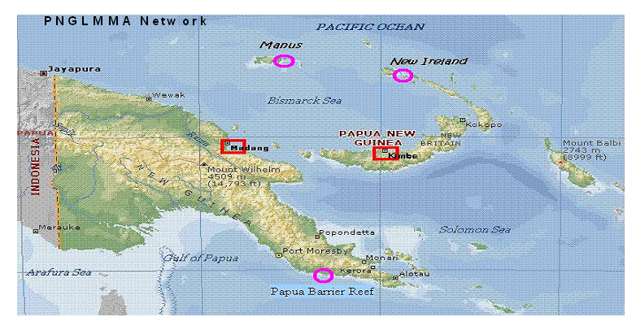
Interest in the LMMA concept began in PNG in when project representatives from Kimbe and Madang attended a regional LMMA workshop in Fiji in 2000. Later that year, a second meeting was held in Bali. In 2002, the concept for the PNG LMMA Network was first introduced at the national PNG Marine Conservation Workshop, and the PNG country LMMA network was formed. Although the LMMA Network

was introduced in PNG in 2002, there was a growing need to continue dialogue with interested projects in Madang Lagoon and Kimbe Bay and to increase overall awareness of LMMA work in PNG.
In May of 2003, the PNGLMMA was officially launched during a national level introductory and capacity building meeting. Project partners from Kimbe Bay (Mahonia na Dari and TNC) and Madang Lagoon (WWF and WIO), and representatives from Manus, Kavieng, Milne Bay and Hiri-East requested membership, and LMMA Network point people at these sites were identified. In the years that followed, several workshops were held throughout PNG to introduce the LMMA Network as well as the Community-Based Adaptive Management concept and the Network's Learning Framework. In 2004, several cross-site visits, trainings and workshops were held to assist Madang and Kimbe project teams carry out activities. In 2005, PNGLMMA Network's first Strategic Planning Workshop was held in Kimbe. Over the next few years, the focus of LMMA work in PNG was on training in biological and socioeconomic monitoring, as well as data management and analysis of collected site data.
In February of 2008, a mini Strategic Planning Workshop was conducted, and the decision was made to incorporate an independent national not-for-profit organisation to coordinate and facilitate PNGLMMA activities. After years of being hosted by long-time partner The Nature Conservancy, PNGLMMA began working in 2008 to establish itself as its own legal entity to carry out its work. In January 2009, PNGLMMA officially became the PNG Centre for Locally Managed Areas Inc. (PNGCLMA), a legally registered not-for-profit organisation based in Port Moresby, to operate as an independent arm of the regional LMMA Network in Papua New Guinea.
The mission of PNGCLMA is to empower local communities to achieve their marine resource management goals by building their capacity in key LMMA management skills, providing a vehicle for sharing their stories and lessons, and supporting the establishment of key partnerships. Strategies include capacity building with community projects; partnership building; awareness, outreach, marketing, and communications; fundraising and sustainability; networking and learning; and governance, management, and administration.”
Also see Talasea Rural Local-Level Government Marine Environment Management Law 2004.

Taken from National Coral Triangle Initiative Coordinating Committee of Papua New Guinea (2012), unless otherwise stated:

Customary Land Tenure
“The land tenure and land utilisation system in Papua New Guinea (PNG) is based on customary land ownership. Ninety‐seven percent of the land is owned by traditional landowners who have the right to decide what does and does not happen on their land. Only 3%, known as alienated land, is controlled by the State. This system supports the largely subsistence non‐cash economy that supports 85% of Papua New Guineans.”

Traditional Knowledge Management
“Many coastal communities in PNG have traditional knowledge that dictates/guides:
1. Ownership of certain sections/zones of the sea,
2. Authority that permits or forbids harvesting,
3. Timeframe/duration of closure and open seasons,
4. Methods of harvesting different marine animals (fishing gear use), and
5. Individuals that harvest (certain clan members, females, newly initiated men etc.)

However, some of the above are eroding at different rates in coastal communities around PNG. This loss of traditional knowledge is caused by; loss of traditional authority, loss of traditional values, population increase and the introduction of a cash economy.”

“Traditional knowledge can also be known as local ecological knowledge. It has been used to facilitate scientific research and protection of marine areas by communities.” Traditional knowledge provides: historical and baseline information, biological and ecological information, marine resource management tools and governance structures, complements other resource management efforts (e.g. the PNG Community Locally Managed Areas), support culturally appropriate management (National Coral Triangle Initiative Coordinating Committee of Papua New Guinea, 2012).

“In PNG, customary rights to locally manage areas are vested in communal clan or families. Therefore any relevant governance structure must reflect this. .... The government has to integrate needs such as promoting conservation practices, using traditional knowledge of coastal communities into overall government planning. We further note that both legal and policy gaps do exist in government policies and legislations for coastal community issues. Therefore the promotion of traditional knowledge could be developed further within existing precedents such as the Bialla Local Level Government (LLG) law on conservation of marine environments.”

“In the overall planning, many coastal areas are of critical significance such as spawning habitats that must be protected. Therefore, the government needs to take that into account when planning for conservation areas based on traditional knowledge that is balanced with formal government control.”

Legislation
Environmental sustainability is enshrined within the constitution of PNG which states in the Preamble to the Constitution:
“we declare …PNG’s natural resources and environment to be conserved and used for the collective benefit of …all,and to be replenished for the benefit of future generations. (Goal Four) As such there is a constitutional basis for the legislative framework that has developed in PNG to manage the nation’s natural resources.

The primary piece of legislation pertaining to the management of natural resources is the Environment Act 2000 (as amended 2002) which became fully operative in 2004. This legislation was developed using Australian legislation as a starting point and replaced three pieces of earlier legislation, namely:
- Environment Planning Act;
- Environmental Contaminant Act; and
- Water Resource Management Act.

“The new legislation aims to streamline the process of environmental management and improves the process of obtaining and monitoring permits for development activities. Key to the Environment Act is the establishment of three levels of development activity (Section 42). The Act and the Environment (Prescribed Activities) Regulation 2002 defines the specific requirements for environmental impact assessment that need to be complied with, in order for permits and licenses to be issued for activities of each level. EIAs are required for level 3 developments and may, in specific cases, also be required for level 2 developments.” “There is no requirement in the Act for Strategic Environmental Impact Assessments (SEA), nor does it appear that such assessments have been ever been undertaken, though such an approach has many benefits for managing environmental impacts.”

“In addition the requirements and penalties for exceeding the conditions attached to permits are detailed within the Act. Stakeholders within the mining, forestry and agriculture sectors indicated that the Environment Act was considerably more stringent than the previous legislation and the penalties for transgressions were more severe. The Act is comprehensive but during the course of this mission a number of stakeholders including the DEC, commented that the focus was on large scale projects and no provision was made for managing the effects of the large numbers of small scale activities that occur in PNG.”

“Under the Organic Law, Provincial and Local Governments may, within limits, make Local Environment Policy.”

Conservation
“Conservation is not included in the remit of the Environment Act and as such is managed under five existing pieces of legislation:
- Fauna Protection and Control Act (1974, 1982);
- The Conservation Areas Act (1980, 1992);
- The National Parks Act (1982);
- International Trade (Fauna and Flora) Act (1993); and
- Crocodile Trade (Protection) Act (1982)”.

Other Legislation
“The Fisheries Act gives broad powers to the Minister of Fisheries and Marine Resources to regulate fishing activity, mainly through prohibition (ban on using explosives) and licensing restrictions. Other pieces of legislation pertaining to fisheries include the Continental Shelf (Living Resources) Act, 1978, the Fisheries (Torres Strait Protected Zone) Act, 1978; the Export (Fish) Regulation Act.”

Other legislation that can be relevant to management of fisheries resources in PNG includes:
The Forestry Act (1991) which covers the management and conservation of forest resources.
- Environmental safeguards, especially pertaining to logging on steep slopes or in proximity to rivers, are provided for by agreements between government and the permit holder. Landowners who cut less than 500 cubic meters per year do not have to obtain a permit;
The Mining Act (which has been under review since 2006);
National Agriculture and Quarantine Inspection Authority (NAQIA) which is responsible for the safe disposal of agricultural chemicals;
National Seas Act;
The Prevention of Pollution of the Sea Act, 1981;
The Dumping of Wastes at Sea Act, 1981; and
The Lands Act.

International treaties, conventions and agreements
“PNG is a signatory to a number of international and regional environmental conventions. While the treaties and conventions may be officially ratified, there is a delay in the associated, national legislation and a clear lack of knowledge of how to implement the status or the contents of the conventions locally.” (See Appendix 3 in National Coral Triangle Initiative Coordinating Committee of Papua New Guinea, 2012)

Legislative institutions
“To date the National Government agencies have had the main responsibility for implementing, monitoring and enforcing the country’s legislation. With the passing of the Organic Law on Provincial Governments and

Local‐level Governments (1995), most of the operational functions could be devolved to the Provincial and/or local governments. However, devolution has been slow to be implemented.

Limitations in capacity and budget are greater constraints at local than at national level and as a result provincial governments and local level government require assistance if they are to take on their legally mandated powers to undertake monitoring and management functions and pass appropriate by‐laws. While awareness of the importance of the environment is growing at National Level, this is not as advanced at provincial, community level.”

Department of Environment and Conservation
“The Department of Environment and Conservation (DEC) is the principal national government agency responsible for management of the country’s environment and environmental legislation. DEC coordinates with other national level departments and authorities (i.e. National Planning and Rural Development, Land and Physical Planning, Agriculture and Livestock, Works, Mining, Petroleum and Energy, Health, Forest Authority, National Fisheries Authority, etc.). DEC also relies on these bodies to undertake some of its duties in addition to their own specific environmental management responsibilities, and to provide logistic support for monitoring visits. The DEC is severely constrained in its operations by extremely limited funding and, in some areas, capable staff.“

National Fisheries Authority (NFA) (source: http://www.fisheries.gov.pg/)
The NFA’s Vision is to “effectively manage our fisheries and marine resources for sustainable and equitable benefits”. “The NFA is a non-commercial statutory authority established and operating under the Fisheries Management Act 1998 and related regulations. Under the Fisheries Management Act 1998, the NFA is responsible for the management and development of the fisheries sector in accordance with the provisions of this Act under the overall policy direction of the Minister and shall perform and exercise its functions and powers on behalf of Papua New Guinea. The functions of the NFA are defined in the Act.”

Refer students to fisheries management information provided by NFA on the EAFM CD under References, then Further Reading and PNG Fisheries Information. Note that only the Reefline Fishery Management Plan has been revised to provide an ecosystem-based management approach.

Further reading:
Anon. (2010) National Fishery Sector Overview of Papua New Guinea. FAO, RomeError: Reference source not found.
Constitution of the Independent State of Papua New Guinea. Chapter 1. Error: Reference source not found
Fisheries Management Act, (1998)Error: Reference source not found.
Kuemlanga, B. (2004) Creating Legal Space for community-based fisheries and customary marine tenure in the Pacific: Issues and Opportunities. FAO/FishCode Review No. 7. Error: Reference source not found
National Coral Triangle Initiative Coordinating Committee of Papua New Guinea. (2012) State of the Coral Reefs of Papua New Guinea. Government of Papua New Guinea, Port MoresbyError: Reference source not found.

PNG Fisheries Management information downloaded from EAFM CD (provided by teacher) in which fisheries legislation, policy and management plans provide information on the in-country fisheries. See under References, then Further Reading.

Unit 7b. Solomon Island coastal fisheries governance

Activity 7b.1. Ask the class to write down what governance is and give examples of what they think is good governance.

There are two main types of governance of fisheries in the Solomon Islands. Like in PNG these can be grouped as formal governance (policy and legislation) or informal governance (traditional management systems). Below are extracts from Sulu et al (2012) on these different governance approaches.

Traditional Management Systems
The main mechanisms of traditional marine resource management are: access control through customary marine tenure (CMT), the articulation of traditional ecological knowledge (TEK) (also referred to as indigenous ecological knowledge (IEK)) for resource management, prohibitions of access (and exploitation of resources) within culturally significant geographical space, and the prohibition of the consumption of certain species. CMT regimes are inextricably linked with the wider social and cultural contexts from which they emerge. Hence, they are tightly embedded with the society’s traditional ecological knowledge (TEK), traditional beliefs, access control and prohibitions, social/ governance structure and other customary practices.

Customary marine tenure (CMT) system is the main form of traditional property ownership and control and this is recognised by the Solomon Islands National Constitution 1978; more than 90% of inshore coastal areas, islands and islets are owned under the CMT system. Under the CMT system, particular groups of people (e.g. family units, clans or tribes) have informal or formal rights to coastal areas and their historical rights to access and use marine resources are, in principle, exclusionary, transferable, and enforceable either on a conditional or permanent basis. Although CMT is the main form of marine property ownership system in the Solomon Islands, studies have been conducted in only a few locations: Lau lagoon, Malaita, Marovo Lagoon, New Georgia, Roviana and Vonavona Lagoon, New Georgia and Nggela. (More details on CMT in these places is provided in Sulu et al 2012 pp 15-18).

The role of TEK in marine resource management is a bone of contention. (Some) argued that it is usually aimed at maximising fisheries production and could potentially contribute to resource depletion. For example, indigenous knowledge contributed to the depletion of the bumphead parrotfish Bolbometopon muricatum by Roviana fishers. In another example, Nggela fishers associated the subtle increases in trochus (catch) at times when the trochus spawn as good times for harvesting.

However, TEK has a role to play when appropriately used in conjunction with conventional scientific data. Traditional knowledge in resource management is especially important in circumstances where fisheries departments are ill equipped by governments to carry out fisheries research or generate knowledge needed for management purposes. Examples of cases where such knowledge was useful for fisheries management are summarised in Sulu et al (2012) (see p. 17).

Although traditional management systems offer advantages for inshore fisheries management in Solomon Islands, modernisation and socioeconomic changes have contributed to its ineffectiveness in some instances in the last 30 years. Some of the significant colluding factors include:
- declining respect for traditional leadership and authority,
- the influence of markets and the commoditisation of resources,
- changing consumption,
- demographic patterns,
- adoption of new religion,
- the demise of traditional belief systems, and
- the uptake of modern gears which are more efficient.

In some instances the effects of such factors have been so pervasive and overwhelming that CMT has not been able to control the decline of some species in sites close to urban areas, e.g. some finfish species, trochus and the green snail (Turbo mamoratus) exported for use in the manufacturing of buttons and jewellery, Holothuria species targeted for the beche-de-mer trade and Tridacna species which are targeted for their adductor muscles (a delicacy in Asia) and their shells for the curio trade.

Despite several inadequacies which beset the effectiveness of CMT for inshore fisheries management, modern day pressures have not generally overthrown these forms of resource management. CMT systems continue to thrive as dynamic socio-political links between local human populations and marine environments and they remain a key dimension in any initiative in coastal resource development in Solomon Islands; in some cases their dynamic and flexible nature meant that under modern day pressures they have undergone organisational innovation and reinforcement. Therefore, although not a panacea in itself, CMT systems still remain an important prerequisite for effective management of marine resources in Solomon Islands.

What is required is a better understanding of how external factors (markets, new laws and legal systems, new forms of religion, new governance systems) impact CMT and, secondly, how the differences and congruencies between CMT and modern methods of fisheries management can facilitate adaptive management systems and at the same time meet community goals and needs. Integration of the CMT system with the modern legal systems for effective fisheries management (or natural resource management in general) is possible and has been done as there are relevant legal provisions in the national legislation which allows for this. For example, the Western Province Natural Resource Management Ordinance and the legal instruments associated with the establishment of the Arnavon Community Marine Conservation Area (ACMCA) allows the establishment of community by-laws for the purpose of resource management, and such by-laws are enforceable by the magistrates court. The fisheries ordinance of the Central Islands Province which is currently (as at February 2012) drafted provides formal powers for the enforcement of customary management systems.

While legal provisions allow such integration, the biggest challenge, however, is in mitigating the pressures of the cash economy in order to achieve compliance. According to John Pita (pers.comm) a conservation officer at AMCA, a major impetus for compliance in AMCA was the provision of alternative means of income generation through the establishment of seaweed farming to the Wagina community who rely solely on marine resources for their livelihood and income generation.

Formal governance
Policy
Policies relevant to the protection and conservation of inshore marine habitats and resources (e.g. coral reefs, seagrass beds and mangroves), are embodied in the general government policies on fisheries and marine resources of successive governments (Anon, Office of the Prime Minister 2008; Anon. Office of the Prime Minister 2010a - both in Sulu et al 2012). Other government documents provide strategies for the protection of coral reefs and marine resources, such as the National Biodiversity and Strategic Action Plan. Substantive policy documents which provide over-arching national strategies to support inshore fisheries

management, conservation, climate change adaptation and ecosystem approaches to resource management are:
- the National Strategy for the Management of Inshore Fisheries and Marine Resources (Ministry of Fisheries and Marine Resources 2010),
- the Solomon Islands Coral Triangle National Plan of Action (Ministry of Environment Conservation and Meteorology & Ministry of Fisheries and Marine Resources 2010) and
- the National Adaptation Programmes of Action (Ministry of Environment Conservation and Meteorology 2008).

The Solomon Islands government is also a party to several regional and international environmental agreements which obliges it to protect, sustainably utilise and manage coral reefs and marine resources.” Refer to Table 1 in Sulu et al (p10) for list of these obligations.

Legislation
Acts of the National Parliament which directly provide for marine environmental protection, sustainable utilisation and management of marine natural resources are: The Fisheries Act 1998, The Wildlife Protection and Management Act (1998), The Shipping Act 1998, The Environment Act 1998 and The Protected Areas Act 2010.

The Fisheries Act 1998 stipulates protection, sustainable utilisation, conservation and management of fisheries resources in general. The Wildlife Protection and Management Act 1998 was enacted with the main objective of complying with obligations under the UNCBD, particularly the trade (both export and import) in wildlife fauna and flora. The Shipping Act 1998 regulates matters pertaining to the protection of marine environment and prevention of pollution from marine vessels; the Act implements various IMO conventions, e.g., the Marine Pollution Convention. The Environment Act 1999 provides for establishing integrated systems of development control, environmental impact assessment and pollution control. The Protected Areas Act 2010 provides for the declaration and management of protected areas where special measures need to be taken to conserve biological diversity and regulates biological diversity and bio-prospecting research.

Activity 7b.2. Ask the class to list the types of governance and specify the difference between the types of governance.

Activity 7b.3: Ask the class to list the roles of the main government institutions in formal governance of coastal fisheries.

Activity 7b.4: Ask the class to give examples of informal governance from the area they come from.

Local scale compliance on conservation/resource management efforts
Despite the existence of laws and regulations and the many conservation initiatives by government, nongovernment organisations and community-based organisations, local compliance remains a challenge. For example, it is common knowledge that dynamite fishing is prohibited by national laws, yet it remains a commonly practiced fishing method in Nggela, Malaita and Guadalcanal. Hunting and consumption of turtle is still common in many parts of the country although people are generally aware that it is prohibited under the fisheries regulations. Sea cucumber harvest closure which is currently in effect is still flouted as resident foreign nationals running businesses in the country continue to purchase illegally harvested beche-de-mer

and find an opportunity to illegally export them out of the country (e.g. Inifiri and Marau 2012; Osifelo 2012 in Sulu et al 2012).

Compliance in community based MPAs remain a challenge (RJS, Pers.obs in Nggela). Even the Arnavon Marine Conservation Area which has fulltime rangers and is the best managed conservation area in the Solomon Islands still has compliance issues (J.Pita pers.comm). On the ground compliance to conservation or resource protection and management laws, regulations and initiatives will remain a challenge for some time into the future. Several reasons for this are: lack of enforcement; the need to meet daily subsistence requirements, to generate income to meet personal needs, and social obligations. Ignorance on the biological aspects of species and the rationale for the environmental legislations and regulations may also be a contributing factor. Increased awareness may probably lead to informed compliance among resource users due to better understanding of the rationale for the fisheries regulations or of the biology and ecology of exploited species and the role of humans in conserving them or exacerbating their demise (Foale, 2006 in Sulu et al 2012).

Compliance to obligations under international treaties and conventions acceded/ratified
Solomon Islands have undertaken steps to comply with its obligations under the environmental conventions it has ratified through the enactment of necessary legislations. Regardless of these efforts, a series of national capacity self assessment studies (McDonald and Lam 2006; McIntyre 2006; Siho 2006; Thomas 2006; Thomas et al. 2006 in Sulu et al 2012) funded by the GEF have identified that significant gaps still exist, which include:
(i) the lack of capacity (both financial and human resources) at the government level to address environmental issues, enforce the legislations or implement necessary local level actions and initiatives,
(ii) the general absence of `government’ at the community level where most environmental issues and actions occur; most local level community resource management and conservation initiatives were driven primarily by non government initiatives and the churches, and
(iii) lack of relevant legislations or where present inherent inadequacies of the environmental legislations occur.

In recent years steps have been taken to address these shortcomings. The enactment of The Protected areas Act 2010 was in response to concerns about the absence of national legislation to establish protected areas for biodiversity conservation, and the lack of provisions within The Wildlife Management and Protection Act 1998 for the in situ protection of endangered species.

The Fisheries Act 1998 is currently being reviewed (The Fisheries Bill 2010) to cater for emerging fisheries related issues; one of the envisaged changes in The Fisheries Bill 2010 will be the provision of a legal basis for the empowerment of local communities to manage their marine resources (Ministry of Fisheries and Marine Resources 2010) and the integration of principles of ecosystem approach to fisheries management (MFMR, Pers. comm).

Activity 7b.5: Describe the pros and cons of formal and informal governance systems in SI.

Further reading:
Sulu, R. J., D. N. Boso, A. Vave-Karamui, S. Mauli, and L. Wini-Simeon. (2012) State of the Coral Reefs of Solomon Islands. Coral Triangle Marine Resources: their status, economies and management. Solomon Islands National Coral Triangle Initiative Coordinating Committee, HoniaraError: Reference source not found.

Solomon Island Fisheries Management information downloaded from EAFM CD (provided by teacher) in which fisheries legislation, policy and management plans provide information on the in-country fisheries. Under References, then Further Reading and then Solomons Fisheries Information.

Unit 8: Fisheries assessments

Student outcomes: Understanding of how to collect and analyse appropriate fisheries and ecosystem information

Information needs for EAFM – why do you need fisheries data?
Information is necessary as a basis for management decisions. As we have seen through the ‘Fish and People’ DVD seriesError: Reference source not found, information about fisheries serves to tell us about the current status of the fishery, but also can be used through time to tell us about trends in our fishery. For example, are target species catches increasing, decreasing or staying the same?

In guidelines for implementing EAFM produced by the FAO (2005)Error: Reference source not found, it is stated that “Information is critical to EAF. It underpins the formulation of national policies, the development of management plans and the evaluation of management progress.” It goes on to state also that EAFM will inevitably need to be based on incomplete information and that the best available information should be used.

This information can be from very different sources including quantitative scientific data collected from fisheries or can be traditional knowledge derived from community interactions with the marine environment over many generations. It is also not only biological and ecological data that is important; we also need to use and collect information that is relevant to the social, economic and cultural aspects of the fishery. Drawing on all sources of information in the EAFM planning stage is critical in identifying key issues that require management intervention. Fisheries data may or may not be used during the initial planning stage depending on data availability; however, fisheries data collection once EAFM is implemented is an important part of assessing the effectiveness of the plan. Fisheries data will enable resource changes to be assessed and will guide modifications to management if necessary (adaptive management). The collection of fisheries data is therefore a critical component of EAFM monitoring.

Types of fisheries data & how to collect them (monitoring)
With respect to the Pacific region, Govan (2011)Error: Reference source not found states “To date the financial costs of scientific research and monitoring appear to have far exceeded investments in actual management of coastal areas. Using locally available information with simple approaches to community monitoring is a cost effective solution, and collaboration with government or regional technical agencies for generating highly technical and specific information such as stock assessment, is another.” There are many different types of fisheries data that can be collected and analysed, depending on the approach to be taken. However, unless agency assistance is available generally a simple ‘data-limited’ approach is warranted.

Traditional knowledge/anecdotes
This the simplest form of data that can be collected and used in assessing and managing fisheries. It is the information individuals gain through their past experiences and can be information about which species were caught in the past, their size, where they were caught, locations of spawning aggregations, etc. The collection of this type of information can by interviewing individuals, especially community elders, or through community meetings. Collecting information requires community co-operation and participation.

Also, caution must be exercised in how much that can be concluded from this type of knowledge simply because accurately remembering past catches can be difficult.

Catch and effort data
One of the simplest and easiest forms of fisheries data to collect is information on the catch taken and the effort to take the catch. Catch can be in numbers or weight of the target species, or both, while effort is recorded as the duration of the fishing trip with the number of people fishing also recorded. The best approach is to identify the key fish and invertebrate species (indicator species) and to focus monitoring on these. Identifying these indicator species should be by a process that involves all community stakeholders. These species may be the fishery target species or species that the community has concerns about. The data can be very easy for community members to collect once shown how. This data can then be used to calculate the catch per unit effort (CPUE), which is a measure of the relative abundance of the species. Examples of CPUE include: number of sea cucmbers collected for every hour spent collecting them for each collector; weight of a target species caught per hour of line fishing for each collector and each fishing line used.

Species size data
Another simple form of fishery data is information on the size of the individuals caught, either using length or weight measurements. This can simply be done by either individuals measuring and recording their catch and passing the information on to others who maintain this data from all fishers in the management area. Alternatively, key personnel can be responsible for visiting fishers on shore or at markets and measuring the catch as a sub-sample of the total catch. Measuring and recording the size of all animals caught is one of the simplest ways of detecting if there are impacts of fishing on the resource.

Underwater Visual Survey (UVS) data
Underwater Visual Surveys (UVS) are usually best done diving on SCUBA so can be a less achievable approach for monitoring fisheries, however in shallow habitats and for some invertebrate species may be done simply on snorkel (e.g. Swimming or manta tows). This approach collects data on the numbers of species of interest and can be used to monitor fish and invertebrate relative abundance (by counting them), size and diversity, or for habitat types and characteristics (eg. % coral cover). Identifying the species and indicators of interest should be by a process that involves all community stakeholders. These species may be the fishery target species or species that the community has concerns about, or habitats that support these species. This approach requires a minimum level of some training to be carried out reliably, so is more resource intensive than collecting size and catch data.

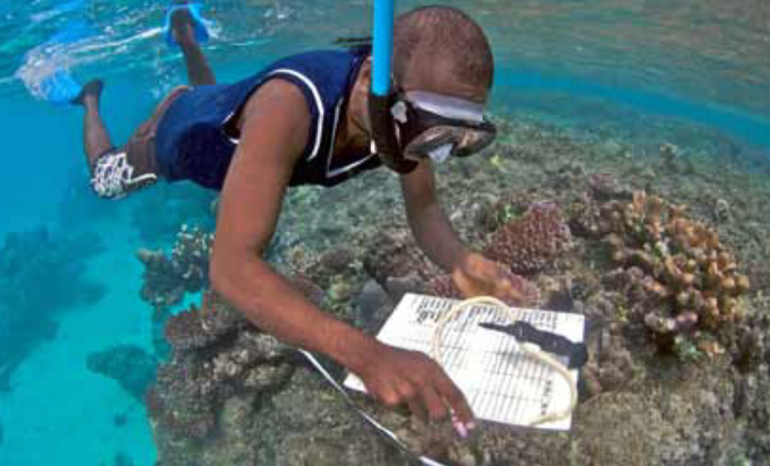
Figure 8.1. Diver conducting an underwater visual survey using snorkel. Source: Albert et al, 2010Error: Reference source not found.

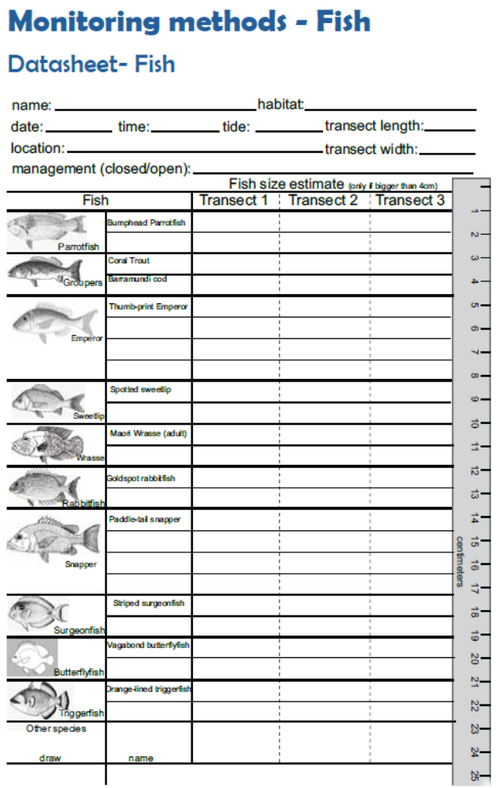
Figure 8.2. Sample UVC data sheet (waterproof paper) carried by divers to record data while swimming each transect. Source: Albert et al, 2010Error: Reference source not found.

Biological samples
Other types of data that can be collected and analysed during monitoring to assist in refining management plans are the age or the reproductive status of the animals caught, which generally requires dissecting parts of the animal. For reproductive data the gonads need to be identified in the body cavity and a determination made on whether they are mature or not, and whether they are male (testes) or female (ovaries). These data are very useful as they can tell us about sex ratios and whether there are enough of each sex for successful spawning or what size (or age) the animal becomes mature. Estimating the age in fish requires dissecting out the otoliths from the brain cavity, storing them and later ‘reading’ them to get an age estimate. The age can be very revealing about an animal as it can tell us how long they live, their growth rates (when coupled with size data), what age they become mature, and the age structure in the population. Tissue samples, often taken as small sections of fins (fin clips), are also simple to collect and can be used to do genetic analyses to determine the stock structure and movement patterns of species. Appropriate storage of these types of samples is required by storing in ethanol solution or freezing.

However, collection and analysis of these types of data requires a far greater level of resources and training. Although these types of data are valuable and informative, in resource limited situations they are not recommended as there are other simpler more cost-effective data types that can be collected and used. Furthermore, species information on age, longevity, and maturity can often be sourced from previous studies conducted elsewhere.

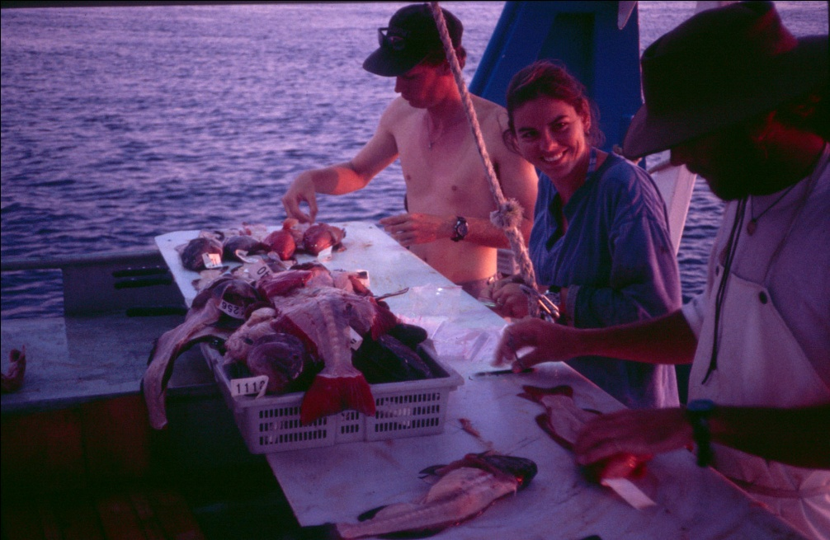
Figure 8.3. Researchers collecting biological samples (otoliths, gonads, fin clips) from coral trout on the Great Barrier Reef, Australia. Photo: Dave Welch.

Social/economic data
Having data about why and how fisheries are important to local communities (and how this changes over time) can also assist in management planning to ensure the continued benefits of fishing. These types of data can be easy to collect by conducting interviews with fishers and the community. The types of data that are likely to be of most use are those that identify what the social and economic benefits of fisheries are to communities, the distribution of those benefits within/among communities, and the information needed to ensure those benefits are maintained (or enhanced should the situation dictate). The types of information this would include are: the number of fishers, their dependence on fisheries (or certain species/gears), how much income derived from fishing, the % of their total income that is derived from fishing, profitability of fishing operations, use of harvested fish (e.g., sold vs. subsistence and if subsistence, who else uses those fish), fishers’ level of involvement in decision-making, etc. Technical advice should be sought to assist in the types of data that may be important and ways to frame interview questions to ensure the right data is collected. (see Pomeroy et al 2004)Error: Reference source not found.

Table 8.1. Summary of some simple fisheries data types, how they are collected and how they can be used to assist in fisheries assessment.
Data type | How collected | What used for | Cost effectiveness
Traditional knowledge/anecdotes | Community meetings; individual surveys with elders | Important fishery sites; indication of historical fishery health (species, sizes, locations); species life history | High
Catch and effort | Record fisher catch (numbers per species) and how long fished, either by surveys or logbooks; regular fishing ‘surveys’ by fisheries officers | Catch-per-unit effort (CPUE) used as an indicator of relative abundance; used to determine population trends | Medium
Size | Fishers or fisheries officers record length and/or weight of fish caught; fish measured in the marketplace | Average size (length or weight) can be calculated and monitored across: species, years, areas, etc | Medium
Underwater Visual Surveys | SCUBA or snorkel transects to record species number, size, habitat type, etc | Numbers/transect give an estimate of relative abundance; species diversity; habitat changes. These can be monitored through time to determine population trends | Low
Biological | Samples can be collected directly independently of fishers; samples can be collected from fisher catches and/or marketplaces. Samples include gonads and otoliths | Used to determine sex and age to derive: growth rates, age/size at maturity, sex ratios, sex change, fecundity | Low
Social/Economic | Survey interviews with community individuals | Determine how fisheries benefit communities; derive strategies to ensure benefits continue | High

Activity 8.1: Ask the class for examples of what fisheries data one may collect, how would they collect it, and how would they use that data. Get them to write these in their notebooks. (10 mins)

DVD: Second half of Module 1: Plenty more fish in the sea? (~ 5 mins) Error: Reference source not found

Using data to assess fisheries

Catch per unit effort (CPUE)
Since CPUE data is a measure of the relative abundance of the resource being monitored, by collecting this data over time we can identify the fluctuations in the species abundance and if there are any trends; whether they are increasing or decreasing (Figure 8.4). A negative or downward trend in CPUE will indicate that the population may be decreasing and therefore is likely to require the amendment of current management or the introduction of new management action that aims to halt and reverse this declining trend. A positive or upward trend in CPUE will indicate that the population may be increasing and may be a sign that current management actions are working. Be careful to also consider other factors that could cause the trend you observe. For example, with greater use of depth sounders and GPS fishermen can find fish more easily thereby increasing their catch rates, even though fish numbers may not be increasing.

Alternatively, we can use these data to assess the current status of fish stocks, or the effectiveness of management by sampling in a managed area and a similar non-managed area. For example, by sampling inside a no-take area (tambu) and concurrently sampling in a fished area, we can compare catch rates to see if fishing is better in one of the areas, and in doing so determine whether the no-take area is having the desired effect of increasing fish stocks.

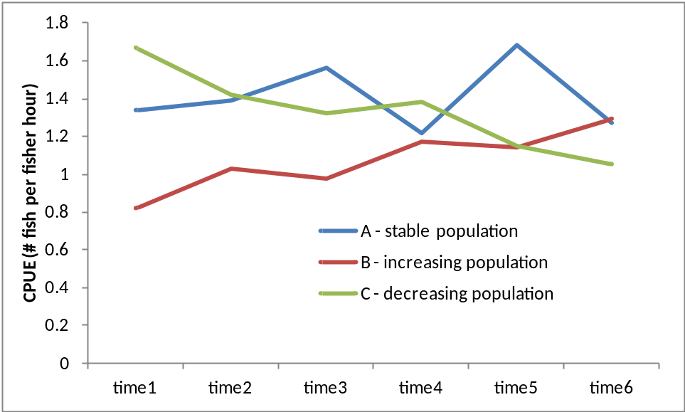
Figure 8.4. Examples of potential changes in catch per unit effort (CPUE) as an indicator of relative population abundance when monitored through time.

Changes in size
Like CPUE data, by monitoring the size of animals in the catch through time we can detect if there are trends that may be positive or negative signs for the population. Size data can be grouped to provide an estimate of the average size of animals in the catch, or as size structures of the catch (or both). Through time we can assess whether the average size is increasing or decreasing with the latter being a sign that overfishing may be occurring since fishing generally targets larger individuals. Figure 8.6 shows an applied management example of the use of average fish size monitored through time.

Either monitored through time or sampled on a single occasion as a ‘snapshot’ of the current status of fish stocks or management effectiveness, size structures can also be very informative as we can see changes in different size classes of animals. An example of this is given below in Figure 8.5 where the top graph shows a healthy population with animals in all size classes present in the population with good relative numbers of large fish. The bottom graph however shows evidence of a population impacted by fishing with very few large individuals present and the most common size class (mode) is shifted to the left of the graph.

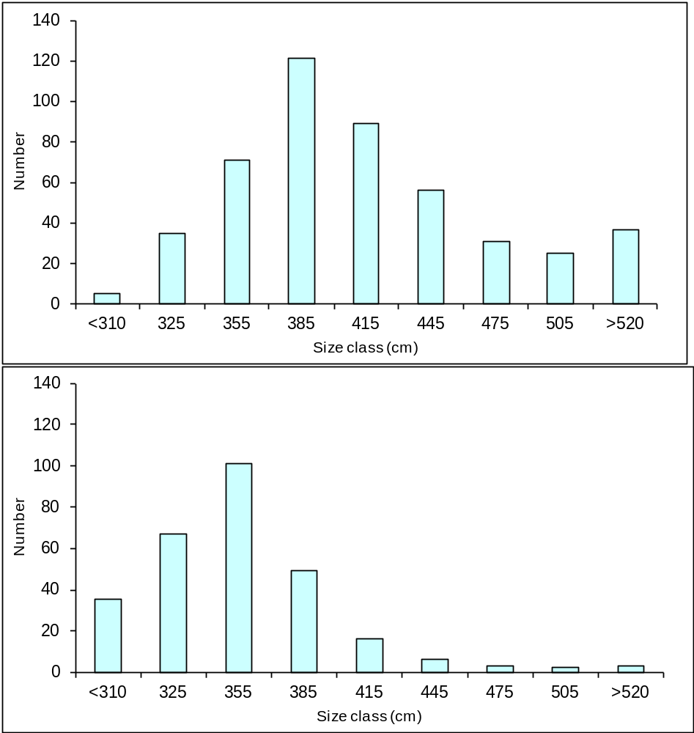
Figure 8.5. Evidence of effects of fishing on coral trout (Plectropomus leopardus) populations using size structures: The top graph shows the size structure of a population on a reef protected from fishing; the bottom graph shows the populations size structure on a reef open to fishing showing that larger fish have been mostly removed from the population. Source: Dave Welch.

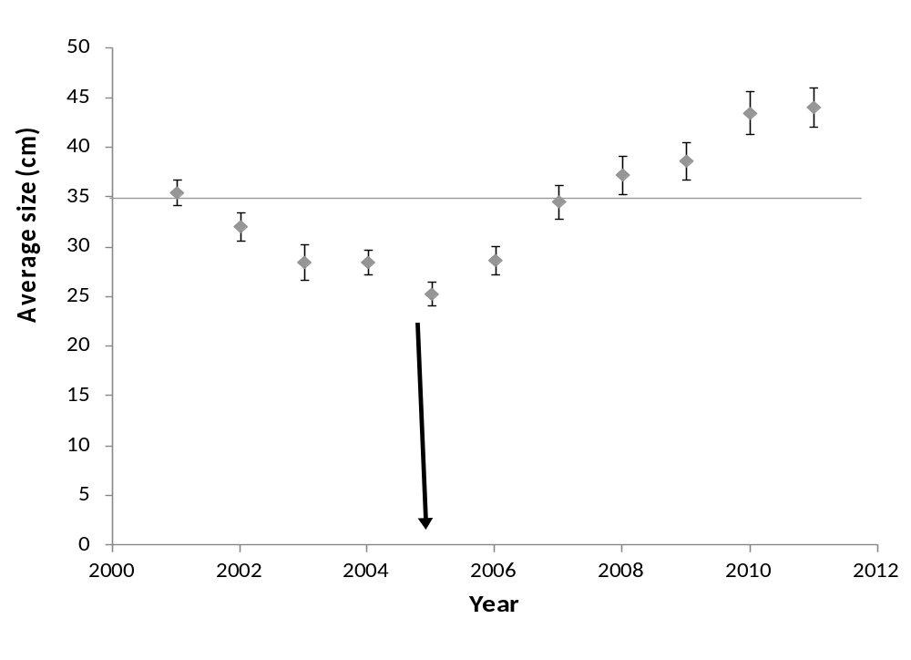
Figure 8.6. Evidence of the effects of fishing on a key target species and the effects that introducing management has had based on simply monitoring the size of animals caught through time. The average size decreased over the time period until 2005 when a minimum size limit of 35 cm was introduced. The increase in average size since the size limit was introduced suggests that the management is working.

UVS data
Like with the use of CPUE data above, UVS data can be as a proxy for the abundance of key species to assess for trends in the fishery populations. It can also be used to assess changes in habitats that are important for fishery species and for overall ecosystem health. UVS involves conducting swims (transects) of a specified distance (eg. 100 m) or time (eg. 5 mins). For fish and invertebrate species the transect will have a specified width usually 3-5 m either side of the transect (Figures 8.7 and 8.8). The diver will swim with a data sheet and board and record their data for key species or species groups within each transect. For habitat it is often carried out by laying a tape along the transect and habitat measurements taken for areas that fall under the tape. By conducting several transects (replicates) for each management area, measurements of relative abundance can be obtained, such as # fish/100 m2 or # fish/min, that are assumed to be representative of the populations. These can be compared among different areas, or by repeating transects each year, so that management effectiveness can be assessed in space and time.

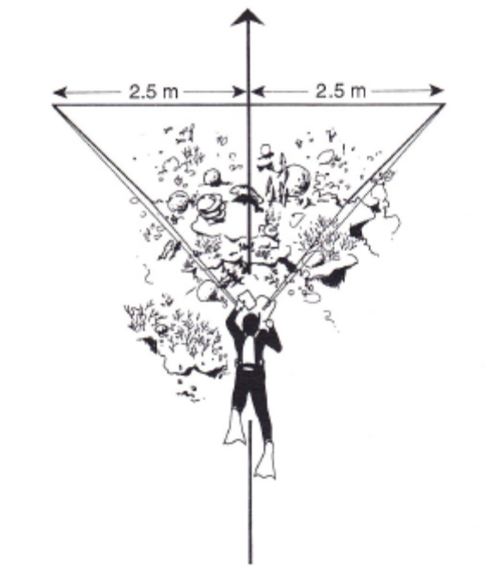
Figure 8.7. Conducting an underwater visual survey requires the diver (or swimmer) to swim the line of the transect tape counting target organisms within the area specified either side of the tape. Source: English et al, 1997Error: Reference source not found.
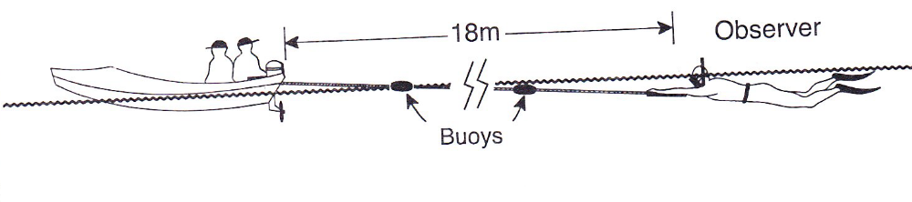
Figure 8.8. Manta tow surveys can be conducted by towing a diver on the surface behind a boat who counts what he observes. Such surveys could be done on snorkel however using the manta tow technique allows far greater area to be sampled. Source: English et al, 1997Error: Reference source not found.

More complex analysis approaches
There are many more complex analyses that can be conducted each with their own data requirements. The more data required then the more resource intensive the monitoring will be so care is needed to choose data and analyses that are appropriate for any given situation. With adequate data available some of the more complex analyses can be tackled. We will not cover other analyses types here since the capacity to collect the relevant data and conduct relevant analyses are likely to be limited in the Pacific region.

Indicators and reference points
Whichever data is available and collected from the fishery, can then be used to calculate measurements that inform us about i) the current status of the fishery, and ii) changes through time in the resource we are managing. Further, these measurements can be used to assess the performance of the management plan and whether it is meeting certain objectives.

The data measures that we decide to use are what we call indicators. By measuring the value of these indicators we can use them to assess whether or not they are at a desirable level that gives us confidence that populations are healthy. These levels are what we call reference points. The target reference point is the desirable value we would like for our indicator, while the limit reference point is the lower limit below which is undesirable. The indicator is judged against these reference points to assess how well are management is performing (performance measure). When the indicator goes below the limit reference point it signals that management is not working and affirmative action is required that is aimed at allowing the measure to go back above the limit reference point. A generalised representation of how indicators are used is provided below in Figure 8.9.

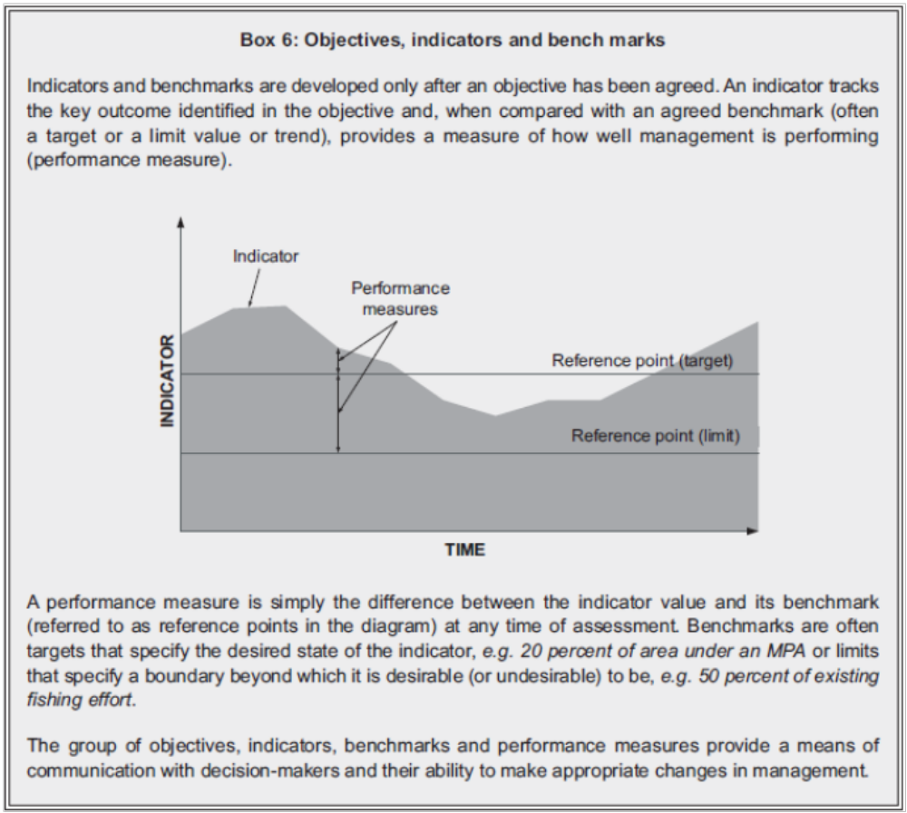
Figure 8.9. A generalised representation of the use of objectives, indicators and performance measures. Source: Staples and Funge-Smith, 2009Error: Reference source not found. For a non-fisheries example of the use of a performance measure against reference points, see Box 15, Ref#EAFM1Error: Reference source not found.

Monitoring is the act of collecting the necessary data to measure our chosen indicator/s. Monitoring can occur at different locations within a management area and the performance measure can be compared among these locations to assess for variation within the management area, while repeating monitoring at these locations

through time (eg. annually) will assess how things change temporally. The performance measure can also be compared among locations within the management area and locations outside the management area. All of these are legitimate ways of assessing the effectiveness of management.

Later in Unit 10 we will talk in more detail about the how to design a robust monitoring program and how to choose indicators and reference point levels.

Activity 8.2: In teams of 4-6 ask the class to calculate basic fisheries statistics using simulated data and identify reference points. Get them to plot some of their data and present this to the class. Each group will need a laptop with the data spreadsheet provided. This activity may require a short tutorial on the use of Excel, eg. using equation editor, using pivot tables, plotting data in graphs, etc. (45-60 mins)

(An alternative approach to this activity would be for the class to visit a site (eg. local MPA) and collect their own data, eg. snorkel transect data on fish/invertebrate numbers, interview local community on effectiveness of the MPA – social, economic, ecological, cultural.)

DVD: Fish and People Module 5: Fish and people: today and tomorrow (12 mins)Error: Reference source not found.

Further reading:
Albert, S., I. Tibbetts, and J. Udy. (2010) Solomon Islands marine lIfe: information on biology and management of marine resources. University of Queensland, Brisbane. (see p62-96) Error: Reference source not found.
English, S., Wilkinson, C. and Baker, V. (1997) Survey manual for tropical marine resources. Australian Institute of Marine Science, Townsville, Australia. 390pp. (Copies can be bought via the Institute at www.aims.gov.au) Error: Reference source not found
Govan, H., Aalbersberg, W., Tawake, A., and Parks, J. (2008). Locally-Managed Marine Areas: A guide for practitioners. The Locally-Managed Marine Area Network. Error: Reference source not found
Haddon, M. (2001) Modelling and quantitative methods in fisheries. Chapman and Hall/CRC Press, Boca Raton, Florida, USA, 406pp.Error: Reference source not found
Pomeroy, RS, Parks, JE and Watson, LM (2004) How is your MPA doing? A guidebook of natural and social indicators for evaluating Marine Protected Area management effectiveness. IUCN, Gland, Switzerland and Cambridge, UK. Error: Reference source not found

